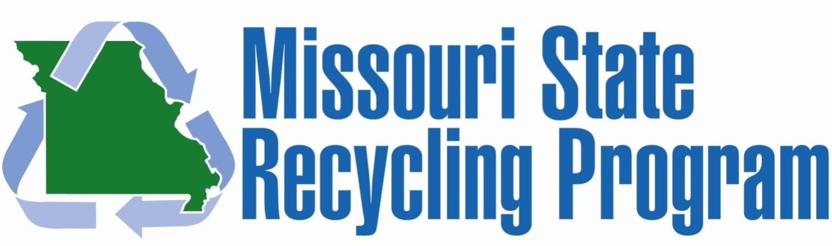
Office of Administration | General Services | 301 W High St, Room 760 | Jefferson City, MO 65101 | 573.751.3384

Calendar of Events

MO Interagency Recycling February 10th, 2015 Runge Nature Center
Committee Meeting Jefferson City, MO

21st Annual Earth Day April 24th, 2015 State Capitol – South Lawn
Celebration / 8th Annual
Zero Waste Challenge

MO Interagency Recycling May 12th, 2015 Runge Nature Center
Committee Meeting Jefferson City, MO

State Employee June 11th, 2015 State Capitol – South Lawn
Recognition Day

MO Waste Control July 12-14, 2015 Lake of the Ozarks, MO
Coalition Conference

MO Interagency Recycling August 11th, 2015 Runge Nature Center
Committee Meeting Jefferson City, MO

MO State Fair August 13-23, 2015 Sedalia, MO
(Recycling at the Fair)

MO Recycling Assoc. September 14-16, 2015 Blue Springs, MO
Conference

MO Recycles Day November 15th, 2015 Statewide

MO Interagency Recycling December 1st, 2015 Runge Nature Center
Committee Meeting Jefferson City, MO

