[Name of Proposed Project Here]
Business Case for Potential Project
Version 1.0
[Enter Date]

Table of Contents
1. Introduction 1
1.1 Project Problem Statement 1
1.2 Background of the Potential Project 1
1.3 Alignment with Strategic Placemats/IT Strategic Roadmap 1
1.4 Is this Project Mandated? 1
2. Business Justification and Impact 2
2.1 Business Need 2
2.2 Return on Investment (ROI) 2
2.3 Project Impact 2
2.4 Business Risk Analysis 2
2.4.1 Risks of Performing the Project 2
2.4.2 Risks of Not Performing the Project 2
3. Project Scope and Success Criteria 3
3.1 Solution Statement 3
3.2 Project Scope 3
3.2.1 In Scope 3
3.2.2 Out of Scope 3
3.3 Objectives 3
4. Cost Analysis 5
4.1 Project Funding Sources 5
4.2 High Level Cost Estimate 5
4.3 Five Year Maintenance and Operations Estimate 6
5. Project Organization 7
5.1 Project Owners 7
5.2 Key Stakeholders 7
5.3 Project Governance Structure 8
5.4 Key Resources 9
6. Key Project Assumptions and Constraints 10
6.1 Assumptions 10
6.2 Constraints 10
6.2.1 Constraint Listing 10
6.2.2 Constraint Prioritization 10
7. Acronyms 12
8. Glossary 13
9. Record of Changes 14

Table of Figures
Figure 1: Project Governance Model 6

Table of Tables
Table 1: Risks of Performing the Project 2
Table 2: Risks of Not Performing the Project 2
Table 3: Business Objectives and Measurements 3
Table 4: Project Funding Sources 5
Table 5: High Level Cost Estimate 5
Table 6: Five Year Maintenance and Operations Estimate 6
Table 7: Project Owners 7
Table 8: Key Stakeholders 7
Table 9: Key Roles and Responsibilities 9
Table 10: Constraint Matrix 11
Table 11: Acronyms 12
Table 12: Glossary 13
Table 13: Record of Changes 14

Introduction

Project Problem Statement
A single, concise sentence that states the business problem that will be solved by undertaking this project.

Background of the Potential Project
Briefly describe the potential project background. Include any historical information, research, or business information which would inform the reader of the general foundational concepts of the project. This section should be written in a manner which is easily interpreted by a layperson unfamiliar with the technical terms and acronyms common to the business.

Alignment with Strategic Placemats/IT Strategic Roadmap
Identify the Vision, Mission, and/or Strategic Goals of the business that are directly related to, or impacted by, the proposed project.

Is this Project Mandated?
Use this section to indicate if the project is mandated. There are generally four sources of mandates. They are Federal, State, Governor and/or IT. If the project is mandated by one of these entities, please state which entity provided the mandate and reference the law or initiative providing the mandate.

Business Justification and Impact

Business Need
The business needs or problems defined in this section should identify those areas which impede the business from fully realizing a specific area of its mission, vision, and/or strategic goals as identified above.

Return on Investment (ROI)
Use this section to estimate hard and soft dollar benefits expected from completing this project.

Project Impact
Use this section to describe less tangible or non-dollar benefits to the citizen, organization, or State as a whole.

Business Risk Analysis
As opposed to the typical risk analysis conducted during the planning phase and related to project activities/deliverables, this is an analysis of the risk(s) to the business of either approving, or not approving the proposed project. This section should include short statements outlining the consequences, penalties, risks, or missed opportunities that may be realized if the project is not done.

Risks of Performing the Project
Table 1: Risks of Performing the Project
Risk | Impact | Response
xx | xx | xx

Risks of Not Performing the Project
Table 2: Risks of Not Performing the Project
Risk | Impact | Response
xx | xx | xx

Project Scope and Success Criteria

Solution Statement
The solution statement should depict the general concept of how the business anticipates solving the business needs and/or problems (e.g., COTS solution, build from scratch, consortium, etc.). The solution should be derived objectively vs. subjectively and the manner by which the business determined the appropriate solution should be explained.

Project Scope

In Scope
The scope elements should be listed at a high level. They will be further elaborated on later in the project.
- xx
- xx

Out of Scope
Sometimes it is as important to state what is out of scope for the project as it is to state what is in scope in order to ensure complete understanding of the scope of the project when entering the planning phase. Any element not listed as “in scope” is considered out of scope of the project. However, specifically the scope of the project does not include:
- xx
- xx

Objectives
Objectives are quantifiable criteria that must be met for the business need or problem to be considered resolved and subsequently for the project to be considered successful. Project objectives must be SMART (Specific, Measureable, Achievable, Relevant, and Time Bound).
A single business need or problem may be resolved by meeting one or more related objectives. In turn, a single objective may impact one or more business needs or problems. Each objective should utilize one or more measurements to support success.

Table 3: Business Objectives and Measurements
Business Need |  | Objective | Measurement | Anticipated Benefit(s)
1 | xx (copy from section 2.1) | 1.1 xx (how are you going to show that you’ve solved the business need) | 1.1.1 xx (how and when are you going to show that you’ve met the objective) | xx (what are the business benefits achieved by this objective)
 |  | 1.2 xx | 1.2.1 xx | xx
2 | xx | 2.1 xx | 2.1.1 xx | xx

Cost Analysis
The costs shown in the tables below are for estimating and guidance purposes. The project budget will be finalized during the project planning phase. While developing a business case there are still many unknown factors when estimating the budget but this section should be completed with estimates based on the information already gathered. The risk contingency is usually between 25% - 50% at this stage. Generally the budget will become clearer when enough is known about the scope and/or project to determine a better estimated budget during the project initiation phase.

Project Funding Sources
Table 4: Project Funding Sources
Funding Source | Amount | Funding Explanation
GR Funds | $0.00 | Explain
Federal Funds | $0.00 | Explain
Other Funds | $0.00 | Explain
Total Available | $0.00

High Level Cost Estimate
Table 5: High Level Cost Estimate
Line Item | Business Case Budget | Comments
Hardware | $0.00
Software/Licenses | $0.00
Consulting | $0.00
Training | $0.00
Agency FTE | $0.00
ITSD FTE | $0.00
Other: | $0.00
Sub-Total | $0.00
Risk Contingency | $0.00
Business Case Budget Total | $0.00

Five Year Maintenance and Operations Estimate
Table 6: Five Year Maintenance and Operations Estimate
Line Item | Business Case Budget | Comments
Hardware | $0.00
Software/Licenses | $0.00
Consulting | $0.00
Agency FTE | $0.00
ITSD FTE | $0.00
Other: | $0.00
5 Year M&O Total | $0.00

Project Organization

Project Owners
Table 7: Project Owners
Project Owner | Interest or role

Key Stakeholders
Table 8: Key Stakeholders
Stakeholder | Interest or role

Project Governance Structure
Insert a screen shot of the proposed project governance structure for this project. See sample below.

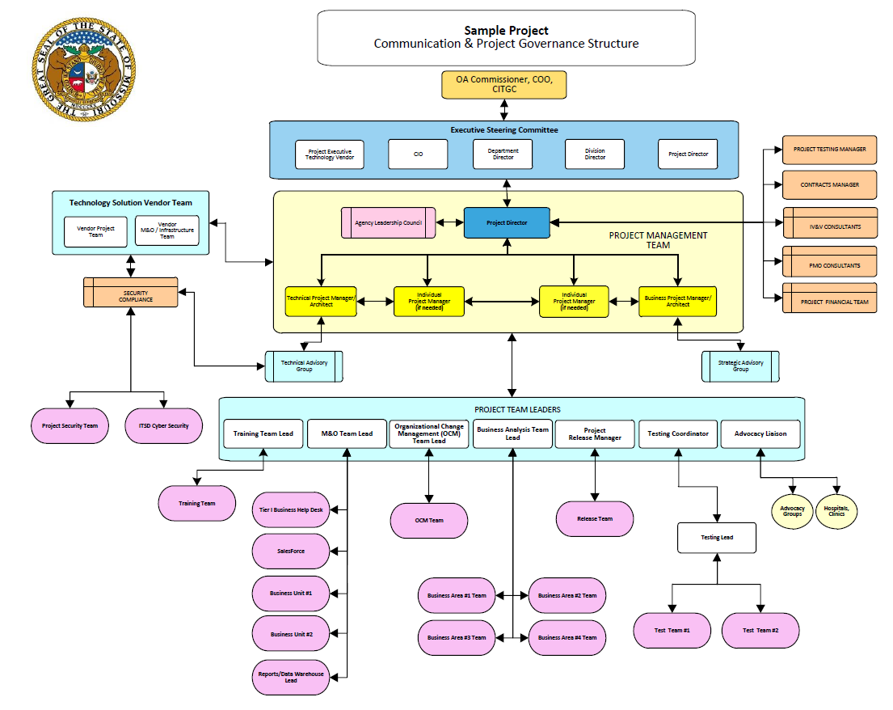
Figure 1: Project Governance Model

Key Resources
This section identifies the key resources that will be assigned to the project. Key resources assigned to the proposed project are outlined below. Additional or alternate resources may be identified and allocated to the proposed project when identified.
Table 9: Key Roles and Responsibilities
Name & Organization | Project Role | Project Responsibilities

Key Project Assumptions and Constraints

Assumptions
Assumptions are factors that, for planning purposes, are considered to be true, real, or certain without proof or demonstration. This section identifies the statements believed to be true and from which a conclusion was drawn to define this business case.
The project has the following assumptions:
- xx
- xx

Constraints
Constraints are defined as the state, quality, or sense of being restricted to a given course of action or inaction. An applicable restriction or limitation, either internal or external, to the project that will affect the performance of the project or a process.

Constraint Listing
This section is used to list any constraints that this project will be working under. Examples may include funding constraints, legislative deadlines, limited personnel, etc.
The project has the following constraints:
- xx

Constraint Prioritization
Cost, schedule, scope, and quality are often in conflict during projects. The sponsor elected to prioritize these constraints as displayed in the following matrix: Consult with sponsor and arrange according to project priority.
- Fixed: no changes are desired in the constraint unless all other options have been exhausted.
- Flexible: a change can occur in this constraint only after the options that made changes in the constraints marked accept are exhausted.
- Accept: the constraint is the first place to adjust to account for a change in the project.

Note on Quality Constraint: Some models of the triple constraint triangle use quality instead of scope as the 3rd leg of the triangle. In many classic situations, when time or cost was strained, it was quality – usually through less testing or verification, but sometimes through dropped characteristics – that was compromised.

Table 10: Constraint Matrix
CONSTRAINT | Accept | Flexible | Fixed
Cost |  | X
Schedule | X
Scope | X
Quality |  |  | X

Acronyms
Table 11: Acronyms
Acronym | Literal Translation

Glossary
Table 12: Glossary
Term | Definition

Record of Changes
Table 13: Record of Changes
Version  Number | Date | Author/Owner | Description of Change

