

[Name of Proposed Project Here]

Business Case for Potential Project

Version 1.1

[Enter Date]

Table of Contents

1. Introduction 1

1.1 Project Problem Statement 1

1.2 Background of the Potential Project 1

1.3 Alignment with Strategic Placemats/IT Strategic Roadmap 1

1.4 Is this Project Mandated? 1

2. Business Justification and Impact 2

2.1 Business Need 2

2.2 Return on Investment (ROI) 2

2.3 Project Impact 2

2.4 Business Risk Analysis 2

2.4.1 Risks of Performing the Project 2

2.4.2 Risks of Not Performing the Project 2

3. Project Scope and Success Criteria 3

3.1 Solution Statement 3

3.2 Project Scope 3

3.2.1 In Scope 3

3.2.2 Out of Scope 3

3.3 Objectives 3

4. Cost Analysis 5

4.1 Project Funding Sources 5

4.2 High Level Cost Estimate 5

4.3 Five Year Maintenance and Operations Estimate 6

5. High Level Project Requirements 8

5.1 Business Process Model (current) 8

6. Project Organization 9

6.1 Project Owners 9

6.2 Key Stakeholders 9

6.3 Project Governance Structure 10

6.4 Key Resources 12

7. Key Project Assumptions and Constraints 13

7.1 Assumptions 13

7.2 Constraints 13

7.2.1 Constraint Listing 13

7.2.2 Constraint Prioritization 13

8. Acronyms 15

9. Glossary 16

10. Record of Changes 17

Table of Figures

Figure 1: Project Governance Model 11

Table of Tables

Table 1: Risks of Performing the Project 2

Table 2: Risks of Not Performing the Project 2

Table 3: Business Objectives and Measurements 3

Table 4: Project Funding Sources 5

Table 5: High Level Cost Estimate 5

Table 6: Five Year Maintenance and Operations Estimate 6

Table 7: Project Owners 9

Table 8: Key Stakeholders 9

Table 9: Key Roles and Responsibilities 12

Table 10: Constraint Matrix 14

Table 11: Acronyms 15

Table 12: Glossary 16

Table 13: Record of Changes 17

# Introduction

## Project Problem Statement

A single, concise sentence that states the business problem that will be solved by undertaking this project.

## Background of the Potential Project

Briefly describe the potential project background. Include any historical information, research, or business information which would inform the reader of the general foundational concepts of the project. This section should be written in a manner which is easily interpreted by a layperson unfamiliar with the technical terms and acronyms common to the business.

## Alignment with Strategic Placemats/IT Strategic Roadmap

Identify the Vision, Mission, and/or Strategic Goals of the business that are directly related to, or impacted by, the proposed project.

## Is this Project Mandated?

Use this section to indicate if the project is mandated. There are generally four sources of mandates. They are Federal, State, Governor and/or IT. If the project is mandated by one of these entities, please state which entity provided the mandate and reference the law or initiative providing the mandate.

# Business Justification and Impact

## Business Need

The business needs or problems defined in this section should identify those areas which impede the business from fully realizing a specific area of its mission, vision, and/or strategic goals as identified above.

## Return on Investment (ROI)

Use this section to estimate hard and soft dollar benefits expected from completing this project.

## Project Impact

Use this section to describe less tangible or non-dollar benefits to the citizen, organization, or State as a whole.

## Business Risk Analysis

As opposed to the typical risk analysis conducted during the planning phase and related to project activities/deliverables, this is an analysis of the risk(s) to the business of either approving, or not approving the proposed project. This section should include short statements outlining the consequences, penalties, risks, or missed opportunities that may be realized if the project is not done.

### Risks of Performing the Project

Table 1: Risks of Performing the Project

|  |  |  |
| --- | --- | --- |
| **Risk** | **Impact** | **Response** |
|  |  |  |
| xx | xx | xx |
|  |  |  |

### Risks of Not Performing the Project

Table 2: Risks of Not Performing the Project

|  |  |  |
| --- | --- | --- |
| **Risk** | **Impact** | **Response** |
|  |  |  |
| xx | xx | xx |
|  |  |  |

# Project Scope and Success Criteria

## Solution Statement

The solution statement should depict the general concept of how the business anticipates solving the business needs and/or problems (e.g., COTS solution, build from scratch, consortium, etc.). The solution should be derived objectively vs. subjectively and the manner by which the business determined the appropriate solution should be explained.

## Project Scope

### In Scope

The scope elements should be listed at a high level. They will be further elaborated on later in the project.

* xx
* xx

### Out of Scope

Sometimes it is as important to state what is out of scope for the project as it is to state what is in scope in order to ensure complete understanding of the scope of the project when entering the planning phase. Any element not listed as “in scope” is considered out of scope of the project. However, specifically the scope of the project does not include:

* xx
* xx

## Objectives

Objectives are quantifiable criteria that must be met for the business need or problem to be considered resolved and subsequently for the project to be considered successful. Project objectives must be SMART (Specific, Measureable, Achievable, Relevant, and Time Bound).

A single business need or problem may be resolved by meeting one or more related objectives. In turn, a single objective may impact one or more business needs or problems. Each objective should utilize one or more measurements to support success.

Table 3: Business Objectives and Measurements

| **Business Need** | | **Objective** | **Measurement** | **Anticipated Benefit(s)** |
| --- | --- | --- | --- | --- |
|  |  |  |  |  |
| 1 | xx (copy from section 2.1) | 1.1 xx (how are you going to show that you’ve solved the business need) | 1.1.1 xx (how and when are you going to show that you’ve met the objective) | xx (what are the business benefits achieved by this objective) |
|  |  | 1.2 xx | 1.2.1 xx | xx |
| 2 | xx | 2.1 xx | 2.1.1 xx | xx |

# Cost Analysis

The costs shown in the tables below are for estimating and guidance purposes. The project budget will be finalized during the project planning phase. While developing a business case there are still many unknown factors when estimating the budget but this section should be completed with estimates based on the information already gathered. The risk contingency is usually between 25% - 50% at this stage. Generally the budget will become clearer when enough is known about the scope and/or project to determine a better estimated budget during the project initiation phase.

## Project Funding Sources

Table 4: Project Funding Sources

|  |  |  |
| --- | --- | --- |
| **Funding Source** | **Amount** | **Funding Explanation** |
|  |  |  |
| GR Funds | $0.00 | Explain |
| Federal Funds | $0.00 | Explain |
| Other Funds | $0.00 | Explain |
| **Total Available** | **$0.00** |  |

## High Level Cost Estimate

Table 5: High Level Cost Estimate

|  |  |  |  |
| --- | --- | --- | --- |
| **Line Item** | **Business Case Budget** | **Core funded or FY NDI Request?** | **Comments** |
|  |  |  |  |
| Hardware | $0.00 |  |  |
| Software/Licenses | $0.00 |  |  |
| Consulting | $0.00 |  |  |
| Training | $0.00 |  |  |
| Agency FTE | $0.00 |  |  |
| ITSD FTE | $0.00 |  |  |
| Other: | $0.00 |  |  |
| **Sub-Total** | **$0.00** |  |  |
| Risk Contingency | $0.00 |  |  |
| **Business Case Budget Total** | **$0.00** |  |  |

## Five Year Maintenance and Operations Estimate

Table 6: Five Year Maintenance and Operations Estimate

|  |  |  |  |
| --- | --- | --- | --- |
| **Line Item** | **Business Case Budget** | **Core Funded or FY NDI request?** | **Comments** |
|  |  |  |  |
| Hardware | $0.00 |  |  |
| Software/Licenses | $0.00 |  |  |
| Consulting | $0.00 |  |  |
| Agency FTE | $0.00 |  |  |
| ITSD FTE | $0.00 |  |  |
| Other: | $0.00 |  |  |
| **1 Year M&O Total** | **$0.00** |  |  |
| **5 Year M&O Total** | **$0.00** |  |  |

*Note: Maintenance costs are incurred on a regular basis to keep an asset working in its optimal condition; this is any expense needed to keep the product running.  It is best to use empirical data when estimating the maintenance cost, however when that is not available the standard for unknown maintenance cost is 20% of the total cost for the project.*

*Maintenance Cost can include, but is not limited to the following:*

1. *Break fixes – when something in the software breaks and prohibits the system from functioning properly*
2. *Software, license, and contract cost (monthly or annual fees) directly tied to the product*
3. *Upgrades needed that are outside the contract cost*
4. *Agency FTE for testing and or review of fixes/upgrades*
5. *Database expenses*
6. *Hardware expenses*

# High Level Project Requirements

## Business Process Model (current)

Document your current (As Is) process. This can be done through a process map or a typed out description of the process. Process mapping improves efficiency and provides a clear picture into a process. A process map helps teams brainstorm ideas for process improvement. They increase communication and provide process documentation. Process mapping will identify bottlenecks, approval issues, wasted steps, and mistakes.

# Project Organization

## Project Owners

Table 7: Project Owners

| **Project Owner** | **Interest or role** |
| --- | --- |
|  | Project Owner is the head of the business unit receiving the product, and bears business responsibility for successful project implementation. |
|  | Steering Committee Members  State of Missouri Senior Management, essential stakeholders with say in how the project is managed. Members meet regularly with Project Director in support, guidance, and decision making to steer the project’s chances of success. Sets the direction, scope, budget, and methods used to realize the project. Resolve conflicts that may arise between departments and stakeholders. Assess, approve or reject project plans or proposed changes to the given plans. |

## Key Stakeholders

Table 8: Key Stakeholders

| **Stakeholder** | **Interest or role** |
| --- | --- |
|  |  |
|  |  |
|  |  |
|  |  |
|  |  |
|  |  |
|  |  |
|  |  |
|  |  |
|  |  |
|  |  |
|  |  |

## Project Governance Structure

Insert a screen shot of the proposed project governance structure for this project. The Project Governance Model can be created using Microsoft Word, Visio, a photo of a hand-drawn structure, or any other method. The Project Governance Model is a complete representation of all product owners, stakeholders, resources, and committees involved in the project. The model represents the flow of approval, communication, and oversight for the project at a glance. See samples below.

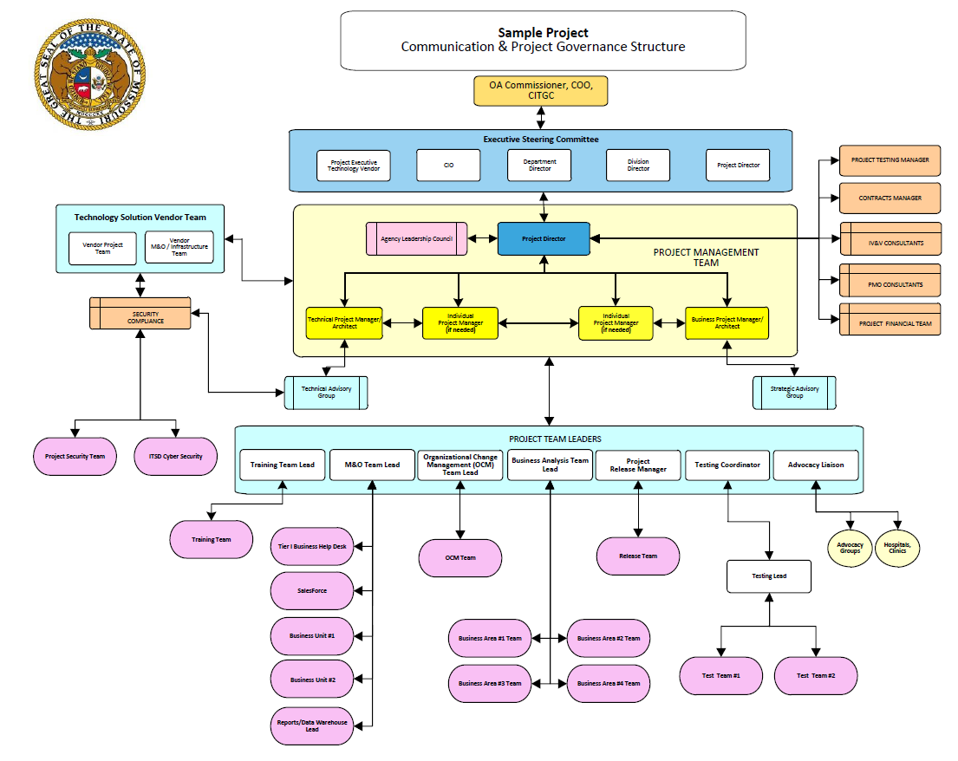

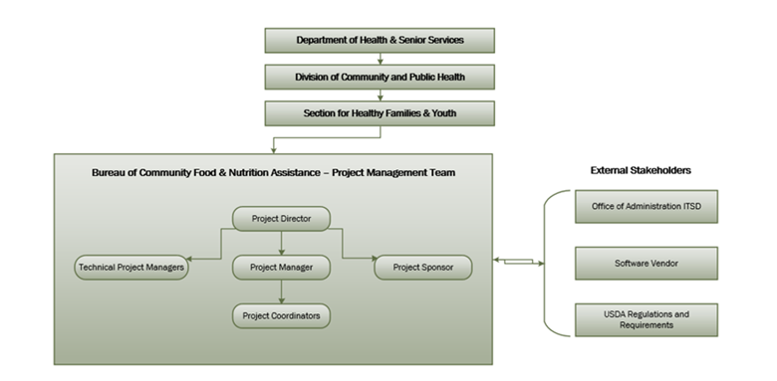

Figure 1: Project Governance Model

## Key Resources

This section identifies the key resources that will be assigned to the project. Key resources assigned to the proposed project are outlined below. Additional or alternate resources may be identified and allocated to the proposed project when identified.

Table 9: Key Roles and Responsibilities

| Name & Organization | Project Role | Project Responsibilities |
| --- | --- | --- |
|  | Project Director | Manages, oversees and makes work assignments to project managers from both the state and vendors. Leader and manager of the overall project and discusses project status, project issues and potential solutions with State of Missouri Senior Management including Department/Division Directors and the ITSD CIO (i.e. Steering Committee). Communicates project status with federal partners, if required. Responsible for managing and working with Project PMO and IV&V Contractors. Works with state cabinet level directors and other state executives in addition to legal counsel to direct the preparation of Project Assessment Quotation (PAQ) and PAQ /bid specifications for submission to vendors. |
|  | Business Project Manager | Provides overall direction, guidance and definition of business architecture to effectively support business strategy. Collaborates across business segments. Creates business architecture models demonstrating how operations and systems interoperate. Leads Senior Management through the development of a business architecture plan for the line of business. Evaluates and presents information that will facilitate effective and timely decision-making. Evaluates project impacts and escalate issues and risk. |
|  | Technical Project Manager | Serve as a subject matter expert on matters surrounding the technical infrastructure supporting the critical project application(s). Investigates, reviews, and evaluates new technology solutions for feasibility and compatibility with current systems and strategic plans. Assesses needs, evaluates application solutions/technologies, hardware, systems, and processes, and makes recommendations to IT leadership. |
|  | Enterprise Architecture | Subject Matter Expert surrounding the technical infrastructure supporting the critical project application(s), and provides the highest level of technical support and coordination for all project infrastructure and the related systems, including networking, core system, and data center. Provides advisory level assistance and project oversight to ensure compliance with IT Department standards, rules, and regulations. |
|  | Project Contract Manager | Assist Project Director with vendor/contract management. Conduct research of readily available sources to inform development of scope of work. Write scope of work statements, PAQs, and RFPs. |
|  | Project Management Office | Support effective project execution by developing the overall program plan addressing both State and solution vendor components of the program. Develop, review, and maintain project artifacts including risk and issue matrices, communication plans, and program and project status reports. Establish adequate program and project structure by establishing a project management methodology and Software Development Life Cycle (the SDLC) with the necessary tools and templates to facilitate the successful completion of the project. Respond to issues and concerns raised by the Independent Validation and Verification (IV&V) team and take appropriate corrective action. |
|  | Project Testing Manager | Coordinates and facilitates meetings to make sure that test planning and testing is moving as needed to meet project deadlines. Works with team to get a testing plan – including test cases needed according to the agreed upon methodology. Coordinates with the PMO/Project Director about testing, issues affecting testing, and metrics. |
|  | Project Release Manager | Coordinates release management with project teams and vendors to plan for each release. Constructs an overall release management schedule with milestones showing key dependencies between components of the release, key phase transitions for various components, how projects are integrated together, shared testing phases, etc. Works closely with deployment engineers to deploy upgrades and patches to the system. Ensures that existing infrastructure is compatible with upcoming releases and conforms to the reference architecture. Coordinates with stakeholders to ensure that the upcoming deployment plans have been properly prepared, reviewed, and approved. |
|  | Independent Validation and Verification (IV&V) | Assesses the overall health of project. IV&V shall participate in key project meetings including weekly project status meetings, requirements gathering, design sessions, risk and issue reviews, reviews of project deliverables, project gate review meetings, and other project meetings deemed necessary by project staff. IV&V staff shall review and provide comments on key project artifacts. Provide recommendations for improvements based on IV&V findings, best practices, and experiences with projects. Develop and execute Security/Privacy Assessment Test Plan. Develop and complete Security/Privacy Assessment Report(s) and Risk Assessment Report(s). |
|  |  |  |
|  |  |  |
|  |  |  |
|  |  |  |

# Key Project Assumptions and Constraints

## Assumptions

Assumptions are factors that, for planning purposes, are considered to be true, real, or certain without proof or demonstration. This section identifies the statements believed to be true and from which a conclusion was drawn to define this business case.

The project has the following assumptions:

* xx
* xx

## Constraints

Constraints are defined as the state, quality, or sense of being restricted to a given course of action or inaction. An applicable restriction or limitation, either internal or external, to the project that will affect the performance of the project or a process.

### Constraint Listing

This section is used to list any constraints that this project will be working under. Examples may include funding constraints, legislative deadlines, limited personnel, etc.

The project has the following constraints:

* xx

### Constraint Prioritization

Cost, schedule, scope, and quality are often in conflict during projects. The sponsor elected to prioritize these constraints as displayed in the following matrix: Consult with sponsor and arrange according to project priority.

* Fixed: no changes are desired in the constraint unless all other options have been exhausted.
* Flexible: a change can occur in this constraint only after the options that made changes in the constraints marked accept are exhausted.
* Accept: the constraint is the first place to adjust to account for a change in the project.

**Note on Quality Constraint**: Some models of the triple constraint triangle use quality instead of scope as the 3rd leg of the triangle. In many classic situations, when time or cost was strained, it was quality – usually through less testing or verification, but sometimes through dropped characteristics – that was compromised.

Table 10: Constraint Matrix

|  |  |  |  |
| --- | --- | --- | --- |
| **CONSTRAINT** | **Accept** | **Flexible** | **Fixed** |
|  |  |  |  |
| Cost |  | X |  |
| Schedule | X |  |  |
| Scope | X |  |  |
| Quality |  |  | X |

# Acronyms

Table 11: Acronyms

|  |  |
| --- | --- |
| Acronym | Literal Translation |
|  |  |
|  |  |
|  |  |
|  |  |
|  |  |
|  |  |
|  |  |
|  |  |
|  |  |
|  |  |
|  |  |

# Glossary

Table 12: Glossary

|  |  |
| --- | --- |
| Term | Definition |
|  |  |
|  |  |
|  |  |
|  |  |
|  |  |
|  |  |
|  |  |
|  |  |
|  |  |
|  |  |
|  |  |

# Record of Changes

Table 13: Record of Changes

| Version  Number | Date | Author/Owner | Description of Change |
| --- | --- | --- | --- |
|  |  |  |  |
|  |  |  |  |
|  |  |  |  |
|  |  |  |  |
|  |  |  |  |