[Name of Proposed Project Here]
Project Business Case and Charter
Version 1.3
[Enter Date]

Table of Contents
Executive Summary 1
1.0 Introduction 2
1.1 Business Problem Statement 2
1.2 Background of the Potential Project 2
1.3 Alignment with Strategic Placemats/IT Strategic Roadmap 2
1.4 Is this Project Mandated? 2
2.0 Project Research and Process Analysis 3
2.1 Business Research 3
2.2 Business Process Model (current) 3
2.3 Business Process Model (future) 3
3.0 Business Justification and Impact 4
3.1 Business Need 4
3.2 Project Impact 4
3.3 Business Risk Analysis 4
3.3.1 Risks of Performing the Project 4
3.3.2 Risks of Not Performing the Project 4
3.4 Return on Investment (ROI) 4
4.0 Project Scope and Success Criteria 5
4.1 Project Scope 5
4.1.1 In Scope 5
4.1.2 Out of Scope 5
4.2 Success Criteria 5
5.0 High Level Technical Requirements 7
5.1 Technical Requirements 7
6.0 High Level Architecture 8
6.1 Architecture Options 8
6.2 Architecture Recommendation 8
7.0 Security Requirements 9
7.1 Security Roles and Processes Plan 9
7.2 Security Options 9
7.3 Security Recommendation 9
8.0 Disaster Recovery Requirements 10
9.0 Cost Analysis 11
9.1 Project Funding Sources 11
9.2 High Level Cost Estimate 12
9.3 Five Year Maintenance and Operations Estimate 13
10.0 Project Organization 14
10.1 Project Owners 14
10.2 Key Stakeholders 14
10.3 Project Governance Structure 15
10.4 Key Resources 16
11.0 Key Project Assumptions and Constraints 20
11.1 Assumptions 20
11.2 Constraints 20
11.2.1 Constraint Listing 20
11.2.2 Constraint Prioritization 20
12.0 Acronyms and Glossary of Terms 21
13.0 Solution Statement 22
14.0 High Level Project Approach 23
15.0 Detailed Project Requirements and Plans 24
15.1 Project Epics 24
15.2 Use Cases 24
15.3 Detailed Requirements 24
15.4 Detailed Entity Relationship Diagram 24
15.5 High Level Data Migration Plan 24
16.0 High Level Project Schedule 25
16.1 Projected Timeframes 25
16.2 Resource Availability 25
16.3 Milestone Schedule 25
17.0 Risk Register 26
18.0 Appendix A 27
19.0 Record of Changes 30

Table of Figures
Figure 1: Project Governance Model 15

Table of Tables
Table 1: Risks of Performing the Project 4
Table 2: Risks of Not Performing the Project 4
Table 3: Business Objectives and Measurements 5
Table 4: Project Funding Sources 11
Table 5: Maintenance and Operations Funding Sources 11
Table 6: High Level Cost Estimate 12
Table 7: One Year Maintenance and Operations Estimate 13
Table 8: Five Year Maintenance and Operations Estimate 13
Table 9: Project Owner 14
Table 10: Key Stakeholders 14
Table 11: Key Roles and Responsibilities 16
Table 12: Constraint Matrix 20
Table 13: Acronyms 21
Table 14: Glossary of Terms 21
Table 15: Risk Register 26
Table 16: Consulting Estimates 27
Table 17: Agency FTE Estimates 28
Table 18: ITSD FTE Estimates 29
Table 19: Record of Changes 30

Document Instructions: Sections 1.0 through 11.0 will be completed by the agency with assistance from the Business Relationship Manager and the assigned Business Analyst as part of a Business Case and will be updated as needed by the Project Intake Office and/or the Project Manager as part of the completion of the Project Charter.

Sections 12.0 to 18.0 will be completed by the Project Intake Team and/or Project Manager with the input from other ITSD and Agency staff as part of the completion of the Project Charter.

Executive Summary
The EPMO Project Intake Office or the Project Manager should complete this section after the business case and/or project charter sections are completed.
[The Executive Summary is a section used for providing a summary of the information contained in the Project Charter. The recommendation is that the executive summary be written in such a way that a person could read only this page and be familiar with the project. Suggestion is to include a short background, what the project is producing, procurements, total budget amount and finish date, and possibly: key business needs and objectives from the charter, key scope elements, or key communication efforts (e.g., public website).]
CIO Recommendation: [Provide the CIO Recommendation if applicable]

1.0 Introduction

Business Problem Statement
A single, concise sentence that states the business problem that will be solved by undertaking this project.

Background of the Potential Project
Briefly describe the potential project background. Include any historical information, research, or business information which would inform the reader of the general foundational concepts of the project. This section should be written in a manner which is easily interpreted by a layperson unfamiliar with the technical terms and acronyms common to the business.

Alignment with Strategic Placemats/IT Strategic Roadmap
Identify the Vision, Mission, and/or Strategic Goals of the business that are directly related to, or impacted by, the proposed project.

Is this Project Mandated?
Use this section to indicate if the project is mandated. There are generally four sources of mandates. They are Federal, State, Governor and/or IT. If the project is mandated by one of these entities, please state which entity provided the mandate and reference the law or initiative providing the mandate.

2.0 Project Research and Process Analysis

Business Research
This section includes the documentation of business research conducted for options, legislative review, feedback from other states, etc. regarding how the business anticipates solving the business needs and/or problems (e.g., COTS solution, build from scratch, consortium, etc.). The information should be derived objectively vs. subjectively and the manner by which the business determined the recommended solution should be explained. This information will be shared with the Enterprise Architecture group for review and the information may be used for a final solution statement.

Business Process Model (current)
Document your current (As Is) processes impacted by this project. This can be done through a process map or a typed out description of the process. Process mapping improves efficiency and provides a clear picture into a process. A process map helps teams brainstorm ideas for process improvement. They increase communication and provide process documentation. Process mapping will identify bottlenecks, approval issues, wasted steps, and mistakes.

Business Process Model (future)
Document your future (To Be) processes based on meetings with agency OpEx representatives and the newly LEANed business processes impacted by the project. This can be done through a process map or a typed out description of the process. Process mapping improves efficiency and provides a clear picture into a process. A process map helps teams brainstorm ideas for process improvement. They increase communication and provide process documentation. Process mapping will identify bottlenecks, approval issues, wasted steps, and mistakes.

3.0 Business Justification and Impact

Business Need
The business needs or problems defined in this section should identify those areas which impede the business from fully realizing a specific area of its mission and vision.
- XX
- XX

Project Impact
Use this section to describe less tangible or non-dollar benefits to the citizen, organization, or State as a whole.

Business Risk Analysis
As opposed to the typical risk analysis conducted during the planning phase and related to project activities/deliverables, this is an analysis of the risk(s) to the business of either approving, or not approving the proposed project. The tables below should include short statements outlining the consequences, penalties, risks, or missed opportunities that may be realized if the project is not done.

Risks of Performing the Project
Table 1: Risks of Performing the Project
Risk | Impact | Response
xx | xx | xx

Risks of Not Performing the Project
Table 2: Risks of Not Performing the Project
Risk | Impact | Response
xx | xx | xx

Return on Investment (ROI)
Use this section to estimate both hard and soft dollar benefits expected from completing this project.

4.0 Project Scope and Success Criteria

Project Scope

In Scope
The scope elements should be listed at a high level. They will be further elaborated on later in the project.
- XX
- XX

Out of Scope
Sometimes it is as important to state what is out of scope for the project as it is to state what is in scope in order to ensure complete understanding of the scope of the project when entering the planning phase. Any element not listed as “in scope” is considered out of scope of the project. However, specifically the scope of the project does not include:
- XX
- XX

Success Criteria
Success Criteria are quantifiable criteria that must be met for the business need or problem to be considered resolved and subsequently for the project to be considered successful. Project Success Criteria must be SMART (Specific, Measureable, Achievable, Relevant, and Time Bound).
A single business need or problem may be resolved by meeting one or more related success criteria. In turn, a single success criteria may impact one or more business needs or problems. Each success criteria should utilize one or more measurements to support success.
Table 3: Business Objectives and Measurements
Business Need #1
Objective

Measurement

Anticipated Benefit(s)
Business Need #2
Objective
Measurement
Anticipated Benefit(s)
Business Need #3
Objective
Measurement
Anticipated Benefit(s)
Business Need #4
Objective
Measurement
Anticipated Benefit(s)

5.0 High Level Technical Requirements

Technical Requirements
This section should be documented by the Business Analyst with assistance from the Business Relationship Managers and Agency based on discussions with the Enterprise Architect and can contain a variety of items including:
- How many users
- Public/Private
- Compliance Requirements
- Concurrent Usage
- # Transactions
- Seasonal Usage

6.0 High Level Architecture
The information in this section should be provided by the Enterprise Architecture and OCS groups and include a diagram generated by the Enterprise Architecture group as well as a recommendation for appropriate direction for architecture.

Architecture Options

Architecture Recommendation

7.0 Security Requirements
This section should be documented by the Business Analyst with assistance from the Business Relationship Manager and agency based on discussions with OCS and the Agency.

Security Roles and Processes Plan

Security Options

Security Recommendation

8.0 Disaster Recovery Requirements
This section should be documented by the Business Analyst with assistance from the Business Relationship Manager and agency based on discussions with OCS and the Agency. Recovery Point Objective (RPO) designates the variable amount of data that can be lost or will have to be re-entered during network downtime. Recovery Time Objective (RTO) designates the amount of “real time” that can pass before the disruption begins to seriously and unacceptably impede the flow of normal business operations.

9.0 Cost Analysis
The costs shown in the tables below are for estimating and guidance purposes. While developing a project business case and charter there are still unknown factors when estimating the budget but this section should be completed with estimates based on the information already gathered. The risk contingency is usually between 15% - 25% at this stage. Generally the budget will become clearer when enough is known about the scope and/or project to determine a better estimated budget during the project initiation phase.

Project Funding Sources
Table 4: Project Funding Sources
Table 5: Maintenance and Operations Funding Sources

High Level Cost Estimate

Table 6: High Level Cost Estimate
*Planned Costs per Fiscal Year should provide the expected expenditures for each line item for each individual fiscal year the project is expected to be ongoing.

Five Year Maintenance and Operations Estimate
Table 7: One Year Maintenance and Operations Estimate
Table 8: Five Year Maintenance and Operations Estimate

Note: Maintenance costs are incurred on a regular basis to keep an asset working in its optimal condition; this is any expense needed to keep the product running. It is best to use empirical data when estimating the maintenance cost, however when that is not available the standard for unknown maintenance cost is 10% of the total cost for the project.
Maintenance Cost can include, but is not limited to the following:
- Break fixes – when something in the software breaks and prohibits the system from functioning properly
- Software, license, and contract cost (monthly or annual fees) directly tied to the product
- Upgrades needed that are outside the contract cost
- Agency FTE for testing and or review of fixes/upgrades
- Database expenses
- Hardware expenses

10.0 Project Organization

Project Owners
Table 9: Project Owner
Project Owner | Interest or role
 | Project Owner is the head of the business unit receiving the product, and bears business responsibility for successful project implementation.
Steering Committee Members
State of Missouri Senior Management, essential stakeholders with say in how the project is managed. Members meet regularly with Project Director in support, guidance, and decision making to steer the project’s chances of success. Sets the direction, scope, budget, and methods used to realize the project. Resolve conflicts that may arise between departments and stakeholders. Assess, approve or reject project plans or proposed changes to the given plans.

Key Stakeholders
This section identifies individuals, agencies and groups that may affect or be affected by this project. Consider other divisions and partner agencies that send and receive data who may need system interface changes, procedural changes, website changes, call center changes, etc., due to the impacts of the project.
Table 10: Key Stakeholders
Stakeholder | Interest or role

Project Governance Structure
Insert a screen shot of the proposed project governance structure for this project. See sample below.

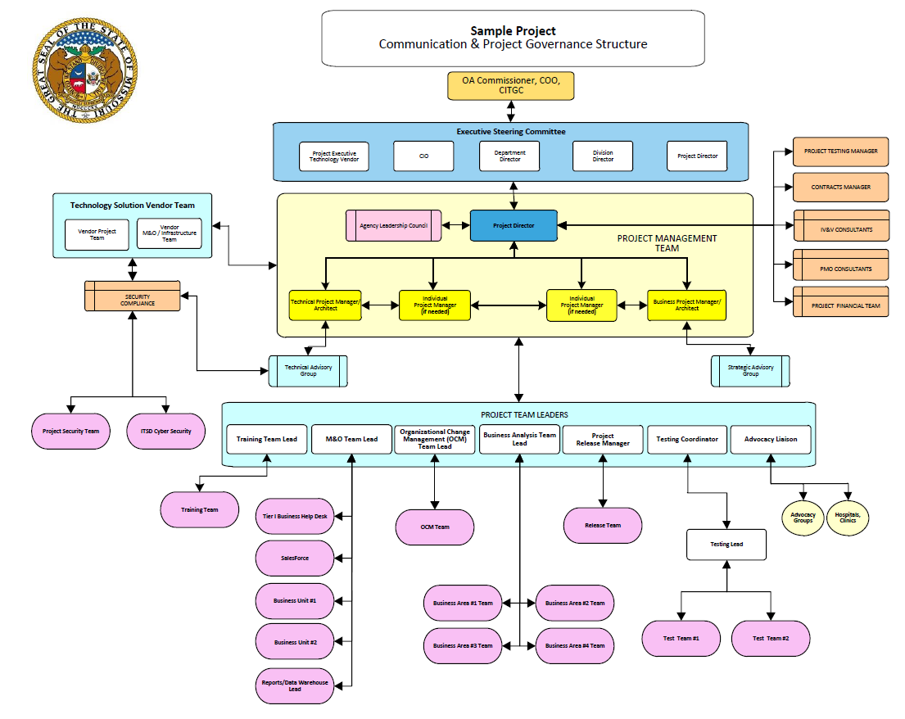
Figure 1: Project Governance Model

Key Resources
This section identifies the key resources that will be assigned to the project. Key resources assigned to the proposed project are outlined below. Additional or alternate resources may be identified and allocated to the proposed project when identified.
Table 11: Key Roles and Responsibilities
Name & Organization | Project Role | Project Responsibilities
 | Project Sponsor | Owns the project and provides resources and support for the project in order to enable its success.
 | Project Director | Manages, oversees and makes work assignments to project managers from both the state and vendors. Leader and manager of the overall project and discusses project status, project issues and potential solutions with State of Missouri Senior Management including Department/Division Directors and the ITSD CIO (i.e. Steering Committee). Communicates project status with federal partners, if required. Responsible for managing and working with Project PMO and IV&V Contractors. Works with state cabinet level directors and other state executives in addition to legal counsel to direct the preparation of Project Assessment Quotation (PAQ) and PAQ /bid specifications for submission to vendors.
 | Business Project Manager | Provides overall direction, guidance and definition of business architecture to effectively support business strategy. Collaborates across business segments. Creates business architecture models demonstrating how operations and systems interoperate. Leads Senior Management through the development of a business architecture plan for the line of business. Evaluates and presents information that will facilitate effective and timely decision-making. Evaluates project impacts and escalate issues and risk.
 | Business Relationship Manager | Act as liaison between agency and ITSD during strategic planning and initiation.
 | Technical Project Manager | Serve as a subject matter expert on matters surrounding the technical infrastructure supporting the critical project application(s). Investigates, reviews, and evaluates new technology solutions for feasibility and compatibility with current systems and strategic plans. Assesses needs, evaluates application solutions/technologies, hardware, systems, and processes, and makes recommendations to IT leadership.
 | Enterprise Architecture | Subject Matter Expert surrounding the technical infrastructure supporting the critical project application(s), and provides the highest level of technical support and coordination for all project infrastructure and the related systems, including networking, core system, and data center. Provides advisory level assistance and project oversight to ensure compliance with IT Department standards, rules, and regulations.
 | Project Contract Manager | Assist Project Director with vendor/contract management. Conduct research of readily available sources to inform development of scope of work. Write scope of work statements, PAQs, and RFPs.
 | EPMO Project Oversight Director | Support effective project execution by developing the overall program plan addressing both State and solution vendor components of the program. Develop, review, and maintain project artifacts including risk and issue matrices, communication plans, and program and project status reports. Establish adequate program and project structure by establishing a project management methodology and Software Development Life Cycle (the SDLC) with the necessary tools and templates to facilitate the successful completion of the project. Respond to issues and concerns raised by the Independent Validation and Verification (IV&V) team and take appropriate corrective action.
 | Project Testing Manager | Coordinates and facilitates meetings to make sure that test planning and testing is moving as needed to meet project deadlines. Works with team to get a testing plan – including test cases needed according to the agreed upon methodology. Coordinates with the PMO/Project Director about testing, issues affecting testing, and metrics.
 | Project Release Manager | Coordinates release management with project teams and vendors to plan for each release. Constructs an overall release management schedule with milestones showing key dependencies between components of the release, key phase transitions for various components, how projects are integrated together, shared testing phases, etc. Works closely with deployment engineers to deploy upgrades and patches to the system. Ensures that existing infrastructure is compatible with upcoming releases and conforms to the reference architecture. Coordinates with stakeholders to ensure that the upcoming deployment plans have been properly prepared, reviewed, and approved.
 | Independent Validation and Verification (IV&V) | Assesses the overall health of project. IV&V shall participate in key project meetings including weekly project status meetings, requirements gathering, design sessions, risk and issue reviews, reviews of project deliverables, project gate review meetings, and other project meetings deemed necessary by project staff. IV&V staff shall review and provide comments on key project artifacts. Provide recommendations for improvements based on IV&V findings, best practices, and experiences with projects. Develop and execute Security/Privacy Assessment Test Plan. Develop and complete Security/Privacy Assessment Report(s) and Risk Assessment Report(s).

11.0 Key Project Assumptions and Constraints

Assumptions
Assumptions are factors that, for planning purposes, are considered to be true, real, or certain without proof or demonstration. This section identifies the statements believed to be true and from which a conclusion was drawn to define this Project Charter.
The project has the following assumptions:
- xx
- xx

Constraints
Constraints are defined as the state, quality, or sense of being restricted to a given course of action or inaction. An applicable restriction or limitation, either internal or external, to the project that will affect the performance of the project or a process.

Constraint Listing
This section is used to list any constraints that this project will be working under. Examples may include funding constraints, legislative deadlines, limited personnel, etc.
The project has the following constraints:
- xx

Constraint Prioritization
Cost, schedule, scope, and quality are often in conflict during projects. The sponsor elected to prioritize these constraints as displayed in the following matrix: Consult with sponsor and arrange according to project priority.
- Fixed: no changes are desired in the constraint unless all other options have been exhausted.
- Flexible: a change can occur in this constraint only after the options that made changes in the constraints marked accept are exhausted.
- Accept: the constraint is the first place to adjust to account for a change in the project.
CONSTRAINT | Accept | Flexible | Fixed
Cost |  | X
Schedule | X
Scope | X
Quality |  |  | X

Table 12: Constraint Matrix

12.0 Acronyms and Glossary of Terms
This includes both agency and ITSD terminology.
Table 13: Acronyms
Acronym | Literal Translation
Table 14: Glossary of Terms
Term | Literal Translation

13.0 Solution Statement
The solution statement should depict the general concept of how the team anticipates solving the business needs and/or problems (e.g., COTS solution, build from scratch, consortium, etc.). The solution should be derived objectively vs. subjectively and the manner by which the team determined the appropriate solution should be explained.

14.0 High Level Project Approach
The project approach begins to define how the project will be accomplished. Some items that may be included are:
- Whether to build or buy
- Whether the product(s) of the project will be delivered iteratively (e.g. phases/releases/tracks, etc.)
- Whether significant, discrete work packages will be managed as official subprojects
- Potential Delivery Resources
  - Verify if the State Data Center services are required for your project

15.0 Detailed Project Requirements and Plans
This section can contain a variety of items depending on the nature of the project. Some items to include here may be:

Project Epics

Use Cases

Detailed Requirements

Detailed Entity Relationship Diagram

High Level Data Migration Plan

16.0 High Level Project Schedule

Projected Timeframes

Resource Availability

Milestone Schedule

17.0 Risk Register
Table 15: Risk Register
ID | Date Identified | Risk Description | Probability | Impact | Severity | Mitigation Plan | Owner | Status Update | Date Closed

18.0 Appendix A
Table 16: Consulting Estimates

Table 17: Agency FTE Estimates

Table 18: ITSD FTE Estimates

19.0 Record of Changes
Table 19: Record of Changes
Version  Number | Date | Author/Owner | Description of Change
1.1 | 1/11/23 | R. Rice | Added Project Sponsor definition
1.2
1.3 | 3/3/23 | R. Rice | Cleared verbiage for instructions

