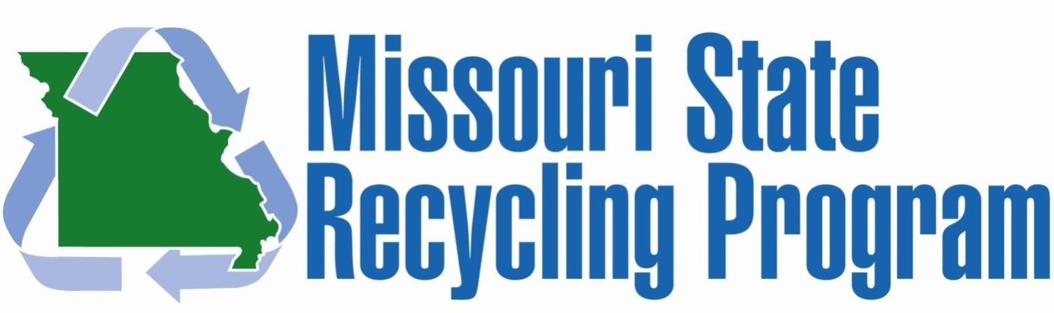
Office of Administration | General Services | 301 W High St, Room 760 | Jefferson City, MO 65101 | 573.751.3384

Recycling Equipment Request Form

Please complete the following questions and return to recycling@oa.mo.gov

1) What is the estimated useful life of the equipment you propose to purchase?

2) How will your organization ensure the equipment will be maintained in good repair and safely stored throughout its useful life? Where will the equipment be stored?

3) Who will be in charge of the equipment? (Please give a position title in the organization, not a specific person’s name).

4) Is training required for those who will operate the equipment? If so, what kind of training is needed and who will provide the training?

5) Describe the current collection process. How will this equipment be utilized to improve collection of the recyclable material?

6) How would this be paid for?

