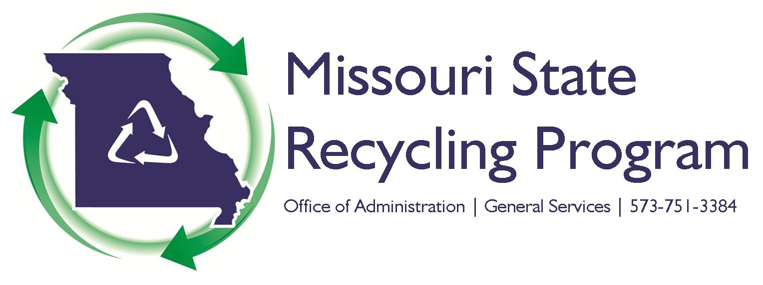

FY18 Recycling Champion Award Overview

The Missouri State Recycling Program annually recognizes state agencies and employees for excellence in recycling. The purpose of this award is to recognize those who have made outstanding contributions in the areas of waste reduction and recycling. Please be aware that nominations emphasizing the benefits to state government will be given more favorable consideration.

Eligibility
You may nominate yourself, a fellow state employee or your state agency for this award. All individual employee nominations must be signed by the employee’s immediate supervisor. All agency / team nominations must be signed by the agency / team manager.

Award Categories
The categories for the award are outlined below. Multiple nominations may be submitted; however, each nomination form may only have one “award category” box checked (either “individual” or “agency”).

Individual Award – This award will be given to a state employee whose actions have significantly furthered waste reduction and recycling within state government. This individual has gone above and beyond the normal recycling duties of their respective position.

Agency Award – This award is given to a team of state employees or a state agency for outstanding contributions in the areas of waste reduction and recycling. The agency / team have gone above and beyond the normal recycling duties of their respective positions.

Nominations

Award nominations must include each of the following three components:

- Completed nomination form – including required signatures.

- A description of how the nominee impacted recycling within their state agency, not to exceed one page.

- Supporting documentation (no more than 5 pages): This could include pictures, measurable results such as cost savings, reduced waste, increased purchases of recycled products, amount of material recycled, etc.

ADDITIONAL INFORMATION ON PAGE 2

Judging – Scoring/Evaluating

The Missouri Interagency Recycling Committee (MIRC) members will judge each nomination using a point system. Each of the following four categories will be scored on a scale of 1 to 5, with 5 being the highest. The nomination(s) with the highest average point total wins.

- Leadership – Has this person or team demonstrated leadership in recycling? How does this benefit the state agency?

- Measurable Outcomes – What are the reductions in time, resources, and cost that can be shown from these efforts? What can be shown as measurable outcomes from this program? How does this benefit the state agency?

- Education and Outreach – What efforts were made to educate and reach state agencies or employees? Is this a program that can be adopted by other state agencies? How does this benefit the state agency?

- Exceeding Standards – How has the nominee exceeded standard state employee / agency recycling efforts? Are there areas where they went beyond the norm? How does this benefit the state agency?

Submission

All documents must be submitted by July 31, 2018 via regular mail, interagency mail, e-mail, or fax to the following address:

Office of Administration
Rob Didriksen, State Recycling Coordinator
Harry S Truman Building, Room 760
301 W. High Street
Jefferson City, MO 65101
Phone: (573) 751-3384
Fax: (573) 751-7819
E-mail: Robert.Didriksen@oa.mo.gov

NOMINATION FORM ON PAGE 3

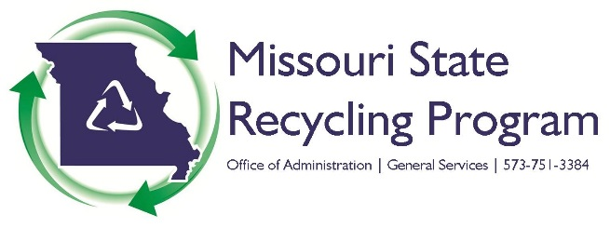

FY18 Annual Recycling Champion Nomination Form

The Missouri State Recycling Program annually recognizes state agencies and employees for excellence in recycling. The purpose of this award is to recognize those who have made outstanding contributions in the areas of waste reduction and recycling. Please be aware that nominations emphasizing the benefits to state government will be given more favorable consideration.

Nomination Requirements
- Completed nomination form – including approval from the immediate supervisor for individual nominations or a manager for agency / team nominations.

- A description of how the nominee impacted recycling within their state agency, not to exceed one page.

- Supporting documentation (no more than 5 pages): This could include measurable results such as cost savings, reduced waste, increased purchases of recycled products, amount of material recycled, as well as pictures etc.

Please select one nomination category and whether it is ok for this nomination to be submitted for a MO Recycling Association award. (this is a fillable form):

Individual Nominee
State Agency or Team Nominee
Is it ok for the State Recycling Program to submit this nomination for a MO Recycling Association award in 2019?

Nominee Information

Name Title Telephone

State Agency Name Division Section

Nominator Information

Name Title State Agency Name

Telephone E-Mail Address

Nominee Approval

Supervisor Printed Name Telephone

Supervisor Signature Date

Please submit the completed nomination form along with the narrative and supporting documentation by July 31, 2018.

