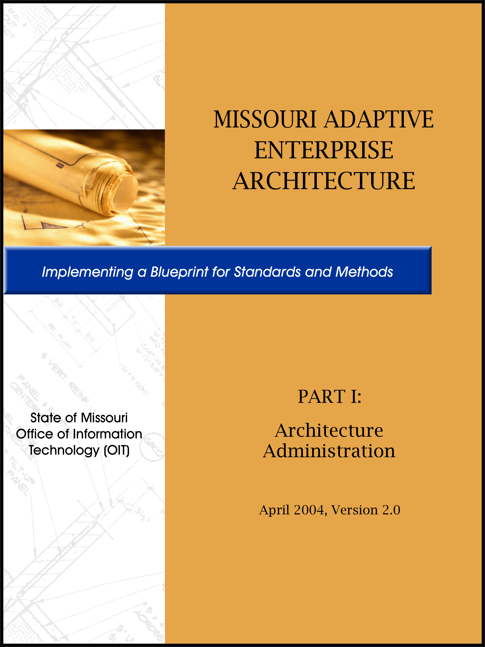
Table of Contents

Overview 2
EXECUTIVE SUMMARY 1
CHAPTER 1: Introduction To Missouri Adaptive Enterprise Architecture 2

EXECUTIVE SUMMARY

Executive Summary

The Missouri Adaptive Enterprise Architecture (MAEA) Manual presents the guidance and approach for development and administration of the Missouri Adaptive Enterprise Architecture Program; as well as information that defines the individual domain architectures; and thus, the Missouri Adaptive Enterprise Architecture Blueprint. The manual presents this information in three parts:

- Part I - Architecture Administration
- Part II - Architecture Process & Templates
- Part III – Appendices

Part I - Architecture Administration provides the introduction to Missouri Adaptive Enterprise Architecture; defines architecture, Architecture Governance, organizational roles and responsibilities; and introduces architectural processes. In addition, Part I provides the enterprise-level business drivers, principles, best practices, and technology trends developed by the State to support the Enterprise Architecture effort.

Part II - Architecture Processes & Templates describes the on-going processes focused on building and maintaining a statewide Enterprise Architecture. It introduces the process models that serve as the basis for documenting the Architecture Blueprint and allow the State to continually evaluate and integrate appropriate technologies to best serve the business of state government and the citizens of Missouri. Part II also includes the Architecture Blueprint-specific templates, which define the Missouri Adaptive Enterprise Architecture, as well as descriptions of the expected content and the process for consistently documenting the Architecture Blueprint.

Part III – Appendices augment Parts I and II of the MAEA Program. Each appendix is included to enhance ones understanding of the MAEA by providing additional information not covered elsewhere in the document. The appendices are as follows:

- Appendix A – Glossary Of Acronyms
- Appendix B – Glossary Of Terms
- Appendix C – Architecture Education Approach
- Appendix D - MAEA Training Evaluation
- Appendix E – Domains And Disciplines
- Appendix F – Enterprise Architecture Repository Manager Overview
- Appendix G – Domain Committee Repository Procedures
- Appendix H – MAEA Framework Entity Model
- Appendix I – EA Component Evaluation Workbook
- Appendix J – Additional Enterprise Architecture Resources

CHAPTER 1: Introduction To Missouri Adaptive Enterprise Architecture

CHAPTER 1: Introduction To Missouri Adaptive Enterprise

Chapter 1 offers an introduction to the Missouri Adaptive Enterprise Architecture program. This chapter identifies the background and business case for architecture as well as an architecture definition, scope of the architecture effort, approach to the architecture program, a definition of program deliverables, and the focus of the effort.

Overview

In July of 1995, as a result of Governor Carnahan’s Commission on Management and Productivity, the Office of Information Technology (OIT) was created. One responsibility identified as part of OIT’s mission was to develop and implement an Information Systems Strategic Plan. One of the primary focus areas identified within that plan was architecture. Also within that plan was a specific primary objective to develop a State of Missouri adaptive Enterprise Architecture that facilitates business system sharing across departmental lines of responsibility.

In December of 2003, Missouri Governor Bob Holden issued Executive Order 03-26 to re-establish the Office of Information Technology. Per this directive, the Office of Information Technology will serve as “the mechanism to coordinate information technology initiatives for the state, particularly with respect to inter-agency initiatives, between executive agencies and local political subdivisions and for the effective development, coordination and adoption of information technology policies.” For administrative purposes, the Office of Information Technology is located within the Office of Administration, and is directed by a Chief Information Officer. The Chief Information Officer has the authority to establish a state enterprise information technology architecture that addresses the technology environment for the State of Missouri with respect to information technology principles, governance, technology and standards; and has the authority to establish state-wide policies with respect to information technology that will contribute to the effective use of information technology within the State of Missouri.

In addition to the stated direction of OIT, the Information Technology Planning Board has stated that architecture is a key area where Missouri State Government should focus information technology. To address architecture issues, the Office of Information Technology and the Information Technology Advisory Board (ITAB) have appointed a technology architecture committee that is charged with the development of the Enterprise Architecture plan. The plan identifies business drivers, architectural requirements, and implementation strategies, taking into consideration current investments as well as future requirements. The plan also identifies rules of governance as well as technical strategies that should be considered, such as reusable components and “buy versus build” decisions.

The goal of statewide Enterprise Architecture is to enhance coordination, simplify integration, build a consistent infrastructure, and generally allow greater efficiencies in the development of technology solutions. The intent of the Missouri Adaptive Enterprise Architecture program is to realize these goals while ensuring effective use of state resources, thereby enabling consistent, effective delivery of services to the employees, citizens, and businesses of Missouri.

Major projects like the Y2K mitigation efforts and the implementation of the statewide accounting system, SAM II, highlighted challenges associated with disparate technology platforms and inconsistent implementation configurations, standards and procedures. The Information Technology (IT) community recognizes that to meet the business needs of the various governmental departments and effectively serve the citizens of the state, the IT infrastructure must allow access to information across department boundaries.

Enterprise Architecture covers the broad spectrum of technology environments to include networks, applications, databases, messaging, interfacing, middleware, security, operations and other relevant architecture disciplines. Guidelines will be developed to facilitate access and consolidation, provide security, eliminate duplication and help ensure that solutions are extensible, scalable, and more easily integrated.

A prime example of the need for consistent standards is evidenced by the current set of database products supported by the State Data Center (SDC). After mainframe consolidation was achieved in calendar year 2000, the data center was required to support at least six separate database products. Each of these products represents investment by the state in purchasing dollars, training dollars, maintenance dollars and technical personnel support. If architectural standards had been in place when these products were purchased, two or three products, not six, could have supported the database function. Similar scenarios exist that could have been addressed with architectural guidelines.

The pervasive use of the Internet is one of the primary drivers of Enterprise Architecture. Citizens have come to expect services to be provided through Internet connections and the state must be capable of responding to those demands. There are currently several departmental web sites that provide information or services. However, there is a broader need to provide integrated statewide services. The current state e-government initiative will provide the first opportunities to establish architectural standards. Future e-government initiatives will be developed in conjunction with standards that will become part of the Enterprise Architecture.

Architectural standards will require an on-going commitment by the state. The evolution of new products, technology trends, business trends and user demands will require a constant update to architectural standards to ensure that data and service remain accessible. Compliance with architectural standards will evolve over a long period of time. One of the outcomes identified in the Information Technology Strategic Plan for Missouri State Government is 100% compliance within 10 years. Specifically, it states that, “The state has 30% architecture compliance in 3 years; and 100% compliance within 10 years.”

The result will be a more effective use of state resources and a more efficient delivery of services.

Architecture Definition

In order to develop Enterprise Architecture, there must be a common understanding of what architecture is. The definition of architecture that will be used in this document is taken from the IBM Systems Journal:

The architecture of an IT system is the structure or structures of the system, which comprise software and hardware components, the externally visible properties of those components, and the relationships among them.

Architecture encompasses functional and operational aspects of the IT system it describes. A complete IT system architecture serves multiple purposes, among them:

- Breaking down the complexity of the IT system so that developers can analyze and design components that are relatively isolated from one another without compromising their ability to integrate them
- Analyzing the functionality so that required technical components (or infrastructure) can be identified
- Assisting in the analysis of service-level requirements so that the means of delivering them can be designed
- Providing a basis for the specifications of the physical computer systems on which the IT system will execute, and providing the basis for the mapping of components onto these computer systems
- The architecture efforts within the State of Missouri are intended to identify and document existing systems, infrastructure, and components, as well as the blueprint for the development of new systems, components, applications, and major modifications to existing systems.

Scope

Managing the scope of the Missouri Adaptive Enterprise Architecture is essential to its success. The scope of the MAEA is defined by those organizations most impacted by its release and where the adoption of the architecture is most influential. Therefore, the Missouri Adaptive Enterprise Architecture will encompass the Executive, Legislative and Judicial branches of state government.

Missouri Universities and local governmental entities were outside the scope of this Enterprise Architecture program. However, where these other government entities are impacted, along with those organizations that do business with the State, is in complying with the State’s interfacing standards. These standards, established by the Missouri Adaptive Enterprise Architecture, will be published and available for review.

Approach

Both the information technology community and state government leaders have determined that information technology architecture is a strategic issue that must be addressed. To move forward with this initiative, the Office of Information Technology (OIT) and the Information Technology Advisory Board (ITAB) began to determine the framework by which architectural standards would be developed. A number of industry experts were consulted and industry standards and best practices were reviewed to determine the approach that best addressed the needs of the State of Missouri.

Meta Group, which had an existing contract with the State of Missouri, was consulted to provide direction and consulting services concerning architectural decisions. Meta provides research and consulting services to information technology organizations and has specific expertise in IT architecture projects. Their architecture templates were used as the basis for the initial design. IBM was also consulted to provide guidance in development of a strategic methodology specific to the State of Missouri e-government initiative. They were also used to identify and apply best practices.

The State of Missouri is currently working with Ciber, Inc. to complete development and documentation of the Architecture Program. Ciber had previously been awarded the architecture category on the State of Missouri’s general services IT contract.

The architectural plans of several other states and the United States Departments of Commerce and Justice were reviewed. NASCIO, an association that represents the Chief Information Officers of the states, has worked on a cooperative effort with the U.S. Department of Justice’s Office of Justice Programs to facilitate governmental information sharing via a national architecture. This effort was chaired by a State of Missouri representative and was also reviewed and considered in Missouri’s project.

A Technology Architecture Committee was appointed to begin identifying architectural principles, business drivers, processes and components relevant to the State of Missouri. Areas of technology pertinent to the implementation of e-government were identified and categorized into natural divisions called “domains”. Initially, eight domains were identified: Interface, Information, Infrastructure, Integration (now named Interoperability), Application, Systems Management, Security and Privacy.

The committee was tasked with developing the template that is used to produce an architecture document for each domain. This group also developed the organizational roles, management responsibilities, and various architectural processes. The organizational roles and responsibilities define how the Enterprise Architecture is maintained and managed. The processes define how the architecture’s vitality is maintained and how governance determines what part of the architecture becomes accepted, revised or rejected.

Once each domain is defined, an Architecture Domain Committee is established to detail the architecture for that domain using a standard architecture template. These committees are comprised of subject matter experts and key stakeholders in the application of these domains. The Security and Information domains were launched in early 2003, followed by the Infrastructure and Interoperability Domains in the fall of 2003. Spring of 2004 will see the launch of the Application and Privacy Domains, with the launch of the Interface and Systems Management Domains expected later in 2004. Additionally, to meet an urgent business need, a “SWAT team” (Scoped Work Architecture Team) was launched to investigate and report on the E-Mail Technology Area.

The State of Missouri also established a close alliance between the IT community and the Division of Purchasing and Materials Management. This alliance is intended to facilitate the exchange of contract information relating to IT initiatives by identifying IT contracts and specific categories relevant to architecture. It is also used as a method of monitoring architecture compliance by monitoring procurement requests.

Architecture Deliverables

The development of adaptable Enterprise Architecture will result in several definable products. Included in these products will be an initial set of domains. Domains will continue to change and new domains will emerge, hence the term adaptable architecture.

Each of the domains will be documented, using a set of standard templates that define the domain’s product and compliance components as well as classifications for these components, including emerging, current, twilight, and sunset. The templates will also identify industry best practices, technology areas associated with the domain and implementation approaches. The collective information documented within these templates is referred to as the Architecture Blueprint.

The Architecture Blueprint templates and the processes for populating the domains are contained in Part II of this manual. These will be used throughout the architecture development effort. The documented Domains will be contained in a repository. Additional information regarding the details of the repository is covered in APPENDIX F – Enterprise Architecture Repository Overview.

A communication process to ensure all relevant participants have access to the statewide architecture information has also been created. This process includes recommendations for procedures within state agencies that ensure a consistent architecture vision. The communication process will include providing version control, as well as web access to the architecture documents.

Focus

The State of Missouri recognizes that the development of Enterprise Architecture is a long term, on-going process. The approach taken by the State of Missouri describes architecture as an adaptable, evolving process providing continuous alignment between the business of state government and technology.

The first step in this process is to focus on the domains that have the most significant impact on the State’s current e-government initiative. The premise is that e-government will be the flash point around which Missouri’s initial architecture domains will evolve. This will allow the various committees to focus on those domain issues that are most relevant and expand as new initiatives are defined.

Benefits of Enterprise Architecture

The development of Enterprise Architecture provides the State of Missouri with a number of benefits that lead to more efficient and more effective IT operations. Some of the key benefits are listed below.

- Enterprise Architecture provides an enterprise-wide IT vision that supports business objectives.
- Best practices and principles are implemented resulting in efficient, rapid response to emerging business needs.
- Expenditures are reduced through lower development, support and maintenance costs. Reusable pattern of architecture also minimize costs.
- Enterprise Architecture provides a clear strategy for procurement and migration.
- Consistent framework provides for better return on existing investment and supports future technology decisions.

CHAPTER 2: MAEA Organization and Administration

CHAPTER 2: MAEA Organization and Administration

Chapter 2 identifies the administration aspects of Missouri’s Adaptive Enterprise Architecture. They include architecture governance, roles and responsibilities, and the governance processes that, in conjunction with strategic plans, project management, and risk assessment requirements, will ensure the architecture remains viable and supports the business of the State.

Architecture Governance Organization

The Missouri Adaptive Enterprise Architecture is governed by a well-defined set of roles, responsibilities, and processes. Like the architecture itself, these areas must be well managed to ensure the effectiveness of the overall architecture. The roles include committees and executives from business and IT whose functions are strategic to the technical committees that make recommendations concerning specific products or standards.

The Architecture Governance processes identified in this manual are an integral part of the overall IT management processes that are used to implement technology solutions within the state. Architecture Governance is closely aligned with Business Strategic Planning, IT Strategic Planning, IT deployment, Project Management and Risk Assessment.

Figure 1 on the following page illustrates the “Missouri Adaptive Enterprise Architecture Governance Model”, which identifies key organizational roles and management responsibilities for the Missouri Adaptive Enterprise Architecture.

Organizational Roles & Management Responsibilities

The support of Enterprise Architecture requires the involvement of personnel in a variety of roles and responsibilities. The State of Missouri has identified the roles and organizational duties at both the State and departmental level. These have been identified in Figure 1. The following provides a narrative description of the identified roles and responsibilities.

Architecture Owner

An executive manager with authority and responsibility for the State’s technology direction owns the Enterprise Architecture. This position exists on two levels. The State of Missouri CIO acts as the Architecture Owner from an enterprise (statewide) perspective. Department CIO's or IT directors act as the Architecture Owner at the department level.
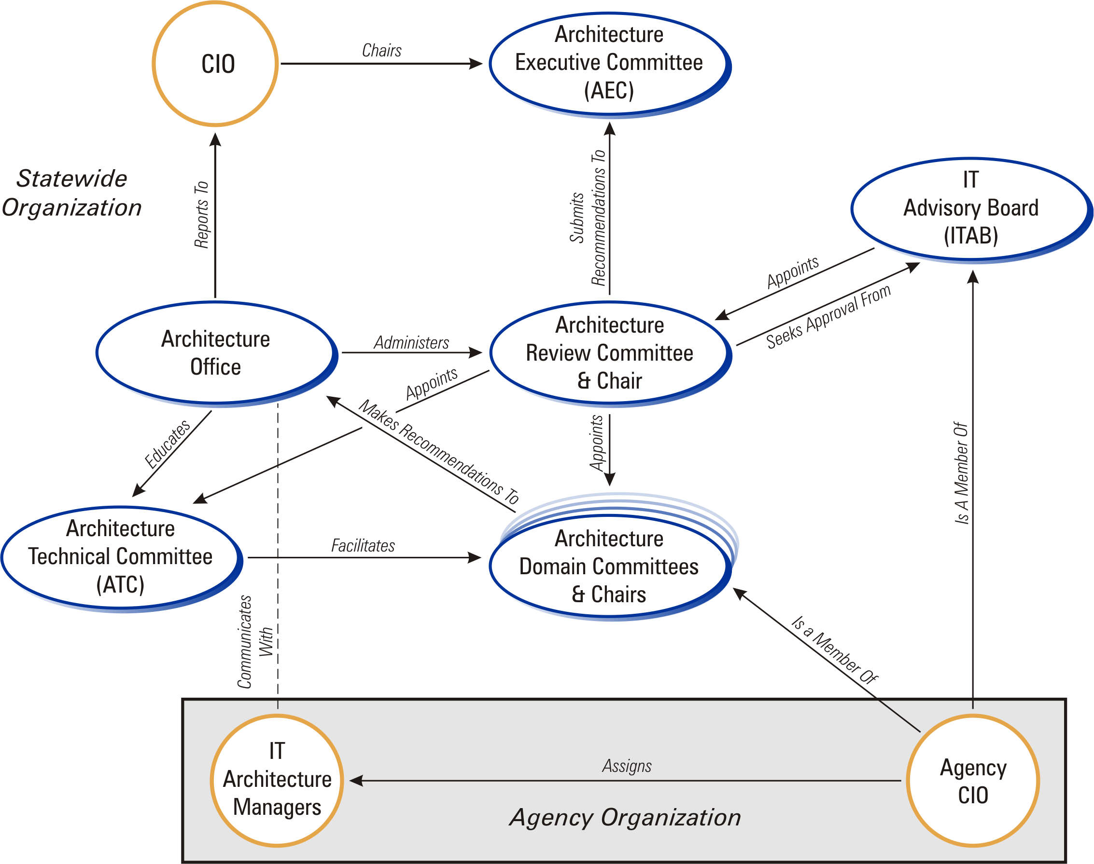Figure 1. Missouri Adaptive Enterprise Architecture Governance Model

Architecture Owner Responsibilities
- Champion the value and effectiveness of the Enterprise Architecture
- Ensure that the on-going implementation of architecture is successful
- Continuously demonstrate the benefits of the Enterprise Architecture
- Ensure conformance of applications and services to the Enterprise Architecture
- Promote understanding and acceptance of the Enterprise Architecture
- Assure appropriate resources are available and assigned to Architecture roles
- Ensure quality and currency of the architecture
- Appoint a core architecture team or Architecture Office to oversee the use, maintenance and communication of the architecture
- Maintain particular focus on managing the Architecture Principles

Architecture Office

The Architecture Office resides within the CIO’s office and is the core architecture team to oversee the development of the MAEA. This team is responsible for the use, maintenance and communication of the Missouri Adaptive Enterprise Architecture at the enterprise level. An Architecture Manager is appointed by the CIO to chair and operate the Architecture Office.

Architecture Office Responsibilities
- Maintain a focus on managing the Architecture Governance processes
- Implement and manage a compliance process to ensure the conformance of IT deployment projects to the Enterprise Architecture
- Implement and manage a vitality process to ensure the currency and accuracy of the Enterprise Architecture
- Implement and manage a communication plan
- Provide education on the Enterprise Architecture to application developers, users and management
- Ensure all committees function appropriately and effectively and with a consistent methodology
- Educate facilitators and domain committee members on the methodology
- Establish and manage architecture targets and measurements
- Establish and manage the architecture implementation plan
- Develop and maintain the architecture templates used for each domain
- Maintain a liaison with other governmental entities and coordinate efforts with external standards-setting bodies
- The Architecture Office chair (Architecture Manager) serves as an ex-officio member of the Architecture Review Committee (ARC)
- Provide administrative support to the ARC
- Act as liaison between the Domain Committees and ARC

IT Architecture Manager

The IT Architecture Manager is responsible for the use and communication of the Enterprise Architecture (e.g. principles, processes, components) on behalf of the Architecture Owner at the department level. Every department will assign an Architecture Manager. The structure and composition of this position is up to the discretion of each department’s IT Director.

Agencies have the latitude to refine the architecture to be more specific when necessary. Agencies also can impose more restrictive time lines for compliance to meet particular needs. Architecture managers should also develop an enterprise view of architecture to ensure consistent implementation across state agencies. These individuals may be assigned to serve as members of the Architecture Technical Committee and could also be members of Domain Committees.

IT Architecture Manager Responsibilities
- Establish and manage a departmental compliance process to ensure the conformance of IT deployment projects to the Enterprise Architecture
- Establish and manage a communication plan within the department
- Provide education on the Enterprise Architecture to application developers, users and management
- Establish and manage architecture targets and measurements
- Establish and manage the architecture implementation plan
- Manage the physical storage and dissemination of the departmental architecture contents
- Maintain a focus on managing the department’s integration with the MAEA governance processes.
- Maintain a liaison relationship with the Architecture Office

Architecture Executive Committee (AEC)

This is an executive committee made up of government business leaders and the state CIO. This group acts as a steering committee to ensure the Enterprise Architecture is aligned with state business needs. The Architecture Review Committee submits recommendations on architecture to the AEC.

Architecture Executive Committee Responsibilities
- Final approval of architectural standards
- Final approval of architecture variance requests based on business cases
- Final approval of changes in Architecture Governance processes
- Assure that other IT processes such as project planning and risk management are consistent with architecture strategies

IT Advisory Board (ITAB)

The Information Technology Advisory Board consists of department level CIOs or IT directors. The ITAB provides for the implementation of strategic plans and develops key IT strategies. It functions as the key contact point for IT project stakeholders and provides staff to committees for developing IT policy and standards.

IT Advisory Board Responsibilities
- Ensures implementation of enterprise strategic plans
- Develops key IT Strategies
- Key contact point for IT project stakeholders
- Provides staff to committees for developing IT policy and standards

Architecture Review Committee (ARC)

The Architecture Review Committee is a statewide committee composed of selected ITAB members appointed by the ITAB chairperson. It consists of a representative cross section of state business operations as well as department size.

The ARC provides a central focal point for ensuring the vitality of the Enterprise Architecture, overseeing architecture governance processes at the statewide level, and initiating relevant domain committees for the support of e-government and other state business initiatives. It supports the Architecture Executive Committee by reviewing the Enterprise Architecture, recommending appropriate changes, reviewing and approving the architecture compliance of IT projects, and providing technical guidance as needed.

Architecture Review Committee Responsibilities
- Establish and maintain effective architecture processes
- Review architectural changes, whether triggered by changes in the business, new technologies, application development feedback or other IT strategy decisions
- Submit recommendations for changes, additions or exceptions to technology domains to the Architecture Executive Committee
- Seek approval of ITAB
- Review requests for variance
- Identify and document new technology domains as appropriate
- Provide technical guidance to the Architecture Executive Committee
- Coordinate updates and revisions through the Architecture Domain Committees
- Appoint the chair and members to the Domain Committees and maintains a liaison role with them
- Appoint architecture facilitators
- Review agency architecture governance processes

Architecture Technical Committee

The Architecture Technical Committee provides the educator and mentor functions to the architecture community. Their primary function is to lend a consistent, enterprise perspective to the architectural processes. They participate in domain sessions and are available for advice and counsel to the users of architecture. They also function to assure that technology areas and components are properly placed and thoroughly addressed within domains.

Architecture Technical Committee Responsibilities
- Serve as methodology experts
- Validate methodology
- Achieve consensus
- Maintain an enterprise perspective on architecture
- Acts as core architecture group to ensure consistent application of architecture
- Provides continuity and knowledge transfer to domain groups
- Acts as a sounding board for Architecture strategies or policy changes
- Provides information or assistance to ARC
- Used to review special projects or issues related to architecture

Architecture Domain Committees

Each Domain identified will be developed and documented by a Domain Committee made up of subject matter experts who are familiar with the State’s IT environment. The objective of the Domain Committees is to develop, select and maintain guidelines, standards and mandates to be documented in the Architecture Blueprint. Each domain consists of a vision statement, domain goals, best practices, technology trends, and general domain standards. Technical product and configuration information needs to be defined along with hardware/software products for each domain, applicable industry standards, and classifications such as current, emerging, twilight, or sunset. Conditional use restrictions must also be identified for components, as they are appropriate.

These committees and the chairperson are established by appointment of the Architecture Review Committee. They are typically made up of subject matter experts and stakeholders from various agencies. They submit their findings, recommendations and deliverables to the Architecture Office who acts as the liaison with the ARC.

Architecture Domain Committee Responsibilities
- Develop and maintain domain content in the Architecture Blueprint
- Assist statewide Architecture Review Committee with compliance studies, product reviews, and architecture change/help requests
- Provide guidance to departments on domain-specific architecture issues
- Provide technical assistance and recommendations on architecture issues

Architecture Governance Processes

The Architecture Governance processes are an integral part of the overall IT management processes that are used to implement technology solutions within the State. These processes include six primary processes and three associated IT management processes.

Primary Processes

- Architecture Documentation Process
- Architecture Review Process
- Architecture Communication Process
- Architecture Compliance Process
- Architecture Vitality Process
- Architecture Change Management Process (Manual Vitality)

Associated Processes

- Management Process, which encompasses these sub-processes
- Project Management Process
- Missouri’s Value Assessment Program (MoVAP) Process
- Procurement Process

Figure 2 illustrates the “Missouri Adaptive Enterprise Architecture Governance Processes”, which identifies key processes for the Missouri Adaptive Enterprise Architecture.

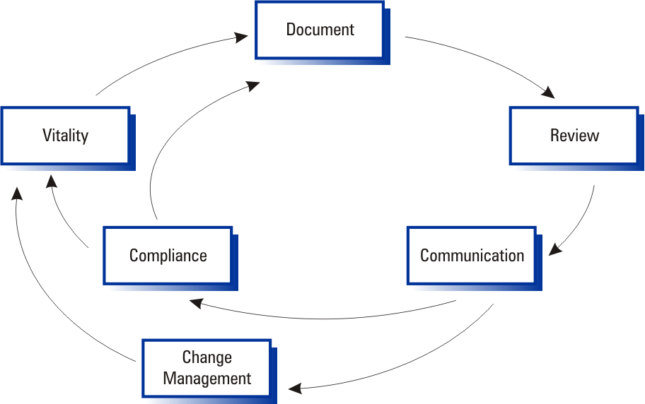Figure 2. Missouri Adaptive Enterprise Architecture Governance Processes

Architecture Documentation Process

The Architecture Blueprint is produced during the documentation process. The Architecture Blueprint articulates the State’s architecture, showing classifications for products and compliances as emerging, current, twilight, and sunset. Products and compliances are also denoted as accepted or rejected during the creation and review of the Architecture Blueprint. From this documentation process a wealth of information can be drawn to aid agencies in determining technology solutions.

The Architecture Documentation Process detail is covered in MAEA Part II: Chapter 1 – Architecture Documentation Process.

Architecture Review Process

The review process allows the Architecture Governance committees to review, debate, discuss, and decide on the various additions and changes to the Architecture Blueprint and MAEA Program. It is also the process that determines which variances will be accepted into the State’s technology portfolio.

The Architecture Review Process detail is covered in MAEA Part II: Chapter 2 – Architecture Review Process.

Architecture Communication Process

The communication process is a required segment of the Architecture. The purpose of this process is to ensure that all users of the architecture understand the objectives of the architecture plan and its significance to the State of Missouri. All users must have access to the latest version of the architecture document in order to make educated decisions about future business and technology. This requires that a mechanism must exist that communicates with all users to ensure that their activities will be synchronized with the plan. The document must also be available to contractors and vendors who expect to do business with the state. In many instances they will be required to conform to the state’s architecture.

The Communications Process detail is covered in MAEA Part II: Chapter 3 – Architecture Communications Process.

Architecture Compliance Process

The State of Missouri IT community has undertaken the development of Enterprise Architecture with the understanding that it is an appropriate and tactically sound approach to managing information technology from a statewide perspective. With general consensus achieved, it is assumed that compliance will be a voluntary process. Agencies will adhere to defined architectural strategies because it is an expedient, efficient and globally accepted process.

However, there will exist circumstances that will preclude the use of the documented standards. A formal compliance process exists to allow for the review and acceptance of variances from the statewide architecture. Agencies will be allowed to submit deviations. These deviations should be presented with an appropriate business case stating the reasons for the variance. Legitimate business cases will be reviewed and those accepted will be documented as approved variances.

The essence of the approval process includes a variety of interests and community perspectives including business needs, IT strategies, budgetary views and legislative activities. Agencies should work toward making their initiatives compliant, or work toward changing the standards. The architecture is not intended to restrict organizations, but is intended to enhance coordination and integration, simplify implementation, build a consistent infrastructure, promote interoperability and generally provide for greater efficiencies.

The Architecture Compliance Process detail is covered in MAEA Part II: Chapter 4 – Architecture Compliance Process.

Architecture Vitality Process

Vitality is the process that ensures the Architecture Blueprint remains current and accurate. This is a major requirement of the overall architectural process. To ensure vitality, the Architecture Blueprint must be reviewed from a business strategy, an IT strategy and a study of technology directions. Input must be provided from the Architecture Executive Committee for the business strategy, and from the ITAB and Architecture Review Committee for the IT strategy. The subject matter experts must ensure that technology solutions are extensible and sustainable.

Any time business strategies, IT strategies or technology solutions make a noticeable shift, an architectural vitality review may be required. At a minimum, these vitality reviews should occur every four to six months as a sound vitality practice.

The Architecture Vitality Process detail is covered in MAEA Part II: Chapter 5 – Architecture Vitality Process.

Change Management Process

Change Management addresses the impacts of the processes, organizational structure, relationships and responsibilities associated with the creation of an enterprise-wide technology architecture. It does not address changes to the Architecture Blueprint itself. The Change Management Process defines how changes to the architecture are addressed and how the MAEA Program will be kept vital.

The Change Management Process will be defined and controlled by the ARC, but the ARC, ITAB, or the AEC may initiate actions.

Details of the Architecture Change Management Process are covered in MAEA Part II: Chapter 6 - Architecture Change Management Process.

Management Processes

Management processes are those processes that are external to the architecture, and yet have links to or are touched by the architecture processes. Currently these processes include:

- Project Management
- Missouri’s Value Assessment Program (MoVAP)
- Procurement

Each of these processes is fully defined in their own right. The process documentation resides within the department responsible for the process. For example the process detail for procurement is documented within the Division of Purchasing and Materials Management.

The Management Processes are currently under development and will be included in MAEA Part II: Chapter 7 - Management Processes.

CHAPTER 3: Business Drivers

CHAPTER 3: Business Drivers

A key factor in developing an adaptive statewide Enterprise Architecture is the understanding of the enterprise business strategies of Missouri state government. The enterprise business drivers document the business direction of the enterprise and help to ensure that the application of information technology supports the business of the State. Adaptive Enterprise Architecture typically includes both business and technical architecture components. Both are equally important and define the roles and processes utilized to document the specific architecture.

To expedite the definition of the technical architecture, one of the initial tasks undertaken by the State in its effort to define Enterprise Architecture was to streamline the development of the enterprise business drivers that guide information technology projects. The State utilized existing business strategic plans and working groups with government leaders to document these business drivers. The initial set of business drivers were documented in 2002. In January of 2004, the Architecture Review Committee updated the business drivers, as well as the principles, best practices, and technology trends for the State. Follow-on efforts to the development of the technical architecture will likely include documentation of the business architecture including the roles, processes, and schedules that ensure the accuracy and vitality of the business perspective of the State.

Enterprise Business Drivers

The Enterprise Business Drivers describe the enterprise-wide business strategies of Missouri state government. They document the business direction of the enterprise and help to ensure that the application of IT support the business of the State. The following list identifies the enterprise business drivers as developed and documented by the state.

ID | DESCRIPTION
EBD 1 | The State of Missouri will make information easily accessible and readily available as needed and wherever needed, for both the citizens of Missouri and the employees. Citizens currently expect to get direct access to government services. In particular, the high availability of information is becoming more and more necessary.
EBD 2 | The State will deliver services in a fiscally accountable fashion. Missouri is a balanced budget government with a constitutional limit on the collecting of taxes and the spending of taxes collected.
EBD 3 | Citizens of Missouri are becoming increasingly aware of new service delivery models. As citizens demand for “faster, better, cheaper” service increases, it will be necessary for the State to provide those services in innovative ways to produce maximum benefit.
EBD 4 | In order to provide expanded services, the State of Missouri must collect increasing amounts of personal information. As a result, it will be necessary for the State to put in place a means to respect and protect the privacy of its citizens.
EBD 5 | All state agencies must cooperate and collaborate in delivering their services. The citizens of Missouri have increased expectations as to the sharing and availability of their personal data. In other words, once it is given to an agency, they expect all agencies to have ready access to it this providing them faster and better services.
EBD 6 | The State will develop processes that allow its services to be delivered as closely as possible to the citizen. Wide varieties of services are available and must be delivered to the citizens in a manner that doesn’t impose inconvenience nor require the citizen’s presence at the central seat of the government.
EBD 7 | The State must continually provide high quality services quicker. As business models for service delivery continue to mature through all categories of industry and government, the levels of citizen expectations continue to rise.
EBD 8 | As government services become increasingly available, it will be necessary for the state to communicate and market those services throughout the entire state, so that all citizens receive the benefits to which they are entitled.
EBD 9 | As Missouri government moves from older process models to 21st century process models, information technology will be a critical success factor in the creation, maintenance and delivery of services to all citizens.
EBD 10 | The current business model under which Missouri State Government functions was adopted in the mid-1970’s. Reorganization of this model to better arrange and provide services is highly probable under future administrations. This newer model is speculated to coordinate business units through similar “Pillars of Government”, such as Benefits Based, Justice & Public Safety, Education, Regulatory & Administration, and Transportation & Engineering.
EBD 11 | Homeland Security efforts require the State of Missouri to take a proactive approach in protecting Missouri’s citizens and securing the State's IT assets and data. This will ensure Missouri Government will continue after a natural or man-made disaster.

CHAPTER 4: Principles

CHAPTER 4: Principles

The Enterprise Architecture principles are the general rules which hold true across the architecture. Likewise, Domain Principles are the underlying general rules that hold true across a specific domain. In a sense, principles define the spirit of the architecture in that they are an attempt to capture the thinking behind it.

The following Enterprise Architecture principles have been identified along with the motivation and implication for each. These statements provide rationale for adhering to the principles, serve as starting points for difficult evaluations and decisions, and guide the design and selection of technology components.

The principles have been grouped into related categories. These principles apply across the enterprise. As domains are developed, references to these overarching principles should be made where appropriate and conflicts with these principles should be addressed.

Enterprise Guiding Principles

ID | DESCRIPTION | MOTIVATION | IMPLICATION
GP1 | Information Technology is an enterprise-wide resource. IT investments will be aligned with the strategic goals of the State of Missouri through planning and architecture processes. | - Align IT policy with agreed business goals  - Reduce implementation and support costs, through a consistent enterprise-wide approach to IT solutions  - Provide support for investment and design decisions  - Consolidate or integrate existing systems and technical infrastructure | - Need to continue to refine the State Enterprise Architecture  - Need to define, refine, implement and/or sustain the following architecture processes:  - Communications (ensuring awareness)  - Compliance (a review process, including an exception process)  - Vitality (a process for ensuring the architecture remains relevant)
GP2 | State IT systems and Enterprise Architecture will support the State’s long-term business, strategies and plans. All development activities will comply with the architecture. | - Enterprise Architecture is adaptive and must evolve to accommodate changes in business and technology.  - Provide the IT foundation to support business process flexibility allowing for on-going business process change (rather than automate a static business model)  - Align and optimize IT resources with changing needs of the business  - Enable the effective implementation of the State’s business strategies  - Highlight and promote the value of IT to businesses/policy makers.  - Highlight credibility by increasing communication.  - Increase utilization of IT (with business alignment) | - Must implement an on-going two way process for aligning and integrating IT strategies and plans with the business  - Must be championed by senior management  - Must define and implement Enterprise Architecture processes (Communications, Compliance, Vitality)  - Strategic outsourcing  - Enable more cohesive strategic planning  - Redefining of IT resources
GP3 | The State of Missouri Enterprise Architecture represents a target IT environment for the State. Departments and agencies will converge on the architecture over time, as new applications are built and deployed, and old systems refreshed or retired. | - Provide a realistic and attainable migration to the Enterprise Architecture | - Must define an explicit transition strategy for existing systems within departments and agencies.  - Must be willing to make difficult decisions to support the long-term enterprise goals, even at the point of potential short-term sub-optimization of the agency.
GP4 | All State Information Technology solutions that deliver products and services to stakeholders will comply with the State Enterprise Architecture. | - Provide an architecture which will enable the State to:  - Respond to changes in technology and business requirements  - Increase consistency, sharing, and accessibility of data  - Ensure interoperability by eliminating ‘islands of technology’ | - Will require significant investments in applications and infrastructure  - Must be championed by senior management  - Must market the value of compliance to our partners, stakeholders, and all personnel throughout the enterprise.
GP5 | Enterprise Architecture is adaptive and must evolve to accommodate changes in business and technology. | - Opportunities exist that can share and re-use IT assets.  - Ensure IT efforts support the needs of the business.  - Leverage the advantages of new technologies while balancing investments in existing systems. | - Will be reviewed and updated regularly through the vitality process.  - Require definition of roles and assignment of responsibilities to ensure:  - The business drivers are understood  - The Enterprise Architecture remains appropriate to the business drivers and the technology environment
GP6 | The CIO, ITAB members, and Domain Chairpersons will provide leadership to the State on the use of technologies to encourage business innovations. | - Identify and leverage the advantages of technologies | - Need for regular and timely communications at strategic levels  - Need for integration of Strategic Business and IT plans  - Need to continually evaluate developments in the marketplace (technologies and practices) in order to leverage business opportunities
MP1 | Accountability will be established for all IT assets – applications, data and technologies. Accountable individuals will be responsible for the management, administration and usage of these assets. | - Ensure accountability for all IT components  - Ensure IT efforts support the needs of the business  - Increase quality of IT solutions | - Must identify applications, data and technologies  - Must define accountability roles and responsibilities  - Must measure the value of the asset  - Must identify individuals accountable for each asset
MP2 | State agencies will adopt an organizational culture that supports architecture. | - Facilitate the process through well-defined roles and responsibilities  - Enhance communication | - Must commit resources and manpower to the process  - Must coordinate activities within agencies
TP1 | Agencies will develop and implement technology solutions based upon industry standards and proven technologies that are in compliance with the Enterprise Architecture. | - Support and align with statewide initiatives and the needs of the business  - Increase consistency, share ability and accessibility of data and applications  - Eliminate ‘islands’ of technology by improving interoperability both within and outside the agencies.  - Reduce the burden of delivering business solutions.  - Ensure a stable long term viable technology and application environment | - Enterprise Architecture management and compliance:  - Must implement processes  - Define roles and responsibilities  - Must market the value of standards across the organization  - Requires a culture change within state IT organizations  - Avoid the proliferation of technologies  - Need for ensuring compliance through a standards compliance process  - Need to develop rigorous and responsive technology selection criteria  - Must allow for emerging technologies within architecture
TP2 | The state agencies will actively seek opportunities to share and re-use IT assets. Where possible IT organizations will implement common sets of technologies and services. | - Reduce costs by eliminating redundant or overlapping investments in technology  - Improve systems management and help desk support through common infrastructure  - Need to develop ‘big team’ concept across IT departments through knowledge networks and workshops  - Stakeholders demanding common business solutions.  - Reduced funds. | - Must look for opportunities to define, fund and staff initiatives (e.g. network, directory, server standardization and consolidation, IT staff rotations, skills development)  - Must be willing to overcome budget constraints and seek alternatives  - Must foster a culture of sharing resources and borrowing technology components  - Need to identify and fund an enterprise-level organization to act as custodian for shared resources.  - Governance must be unified toward the goals of the business.  - Must have a centrally governed architecture.
TP3 | Technology must focus on population demographics and economic issues championed by the policy makers. | - Increased diverse needs of the population.  - Increase in expectations of population  - Economic indicators and population demographics will increasingly impact public policy as never before  - The critical economic issues identified by policymakers (i.e., health, welfare, education, economic development, and land use) will require CIOs to proactively integrate economic policy with IT strategy and execution | - Business and IT strategic plans must address this direction. Specific actions need to be developed to support the growing and changing demands of the population and the legislature.  - EA must synthesize the plan and adjust the technology selection criteria, guidelines, standards, and choices to align the IT solutions to meet these needs.
TP4 | The State of Missouri will secure critical infrastructure in a way that protects the health, safely, and welfare of the citizens and their interests. | - Vulnerable to attacks/disasters  - To properly recognize cyber-security and information threats  - Fundamental services must always continue (business continuity)  - To ensure public safety, health, and welfare of all Missouri citizens  - Increase the ability of government to provide continuous services particularly in times of disaster.  - To enable the planning, prevention, mitigation, remediation, and response to homeland security.  - Homeland security initiatives will accelerate cross-jurisdictional collaboration efforts among federal, state, and local governments  - Initial implementations must focus first on public health and safety  - The leadership provided in the creation and operation of the Department of Homeland Security will pave the way for broader cross-jurisdictional initiatives | - Must deliver services regardless of disabled infrastructure components (e.g., network backbone)  - Costly to achieve  - Increased communication and collaboration amongst agencies  - Paradigm shift from independent behaviors to an inter-dependency that affects an enterprise view  - Architecture needs to out in front  - Must take on a risk posture  - Must invest in R&D  - Must balance privacy and security  - These efforts will form the basis for collaboration and information sharing across state and local governments, private industry, and citizens.  - Adopt common “meta-data” standards for electronic information relevant to homeland security.  - Difficult to implement due to differences in governmental structures
TP5 | Leverage statewide project and oversight processes as a way of increasing the State’s and individual agencies ability to deliver quality products and services with in budget limitations. | - Decreased funding  - Increased expectations (from the citizens to the legislators)  - Policy makers will start making IT decisions for us  - Public-sector budget realities will result in a shift of traditional funding practices | - Reduce time to market (delivery)  - Focus on services  - Need to develop systems to support capturing and tracking of project and the progress they are making  - Organizations must make changes to incorporate project and oversight activities  - Cross agency collaboration and sharing of information
TP6 | The State of Missouri IT community will be financial accountable for selecting, deploying, building, and maintaining solutions for the citizens and stakeholders of the enterprise. | - It is good stewardship; “The right thing to do”  - IT funding will be based on verifiable results  - Exposed view into government operations is resetting public expectations  - Economics, and accountability drive IT funding as never before  - Alternative funding models will form the basis of ongoing IT initiatives  - Budget restrictions will force the need for greater IT accountability | - Budget issues, constraints, and scrutiny  - Need to obtain industry benchmarks to establish a baseline for performance  - Impacts due to external IT mandates  - Need to focus on the management of infrastructure and “what we already have”  - Budget staff will require measurable ROI
TP7 | Metrics will be utilized as a way to measure progress in technology standardization and success in delivering technology solutions. | - Without metrics in place we may be unaware if we are succeeding or failing  - Business cases, benchmarking, and scorecards will see greater adoption in the public sector | - Establish measurable criteria  - Establish and adopt metrics based processed  - Train and mentor staff  - Develop metrics tools kit  - Processes and metrics
TP8 | The State of Missouri must develop a seamless, reliable, secure, and “always available” network and infrastructure to support the growing demands of our citizens and constituents. | - Citizens are online all the time  - Citizens demand to be participants in their government and expect services 24 hours a day, 7 days a week  - Promotes economic development by reaching the greatest amount of people in a timely, yet efficient fashion  - Everything we do relies on a functional, secure, seamless, and reliable infrastructure  - Supports the “continuous services” business driver  - Improve delivery, efficiency, and accessibility of government services to the public. | - We need 99.999% availability  - Must provide a scalable/reliable foundation that is flexible yet secure; today it is not  - Without a robust IT infrastructure, services will be inconsistent, slow, or failed in stakeholders view  - Must deliver services wherever and whenever  - IT is the only logical and feasible way to do this  - Costly to achieve  - Infrastructure funding has to be continuous and current models need to change  - Establish and follow standards  - Well established and known migration strategies  - Increased communication amongst agencies  - Avoid the “bleeding edge” without consulting enterprise impact
TP9 | All agencies will follow state architecture practices and adopt technology directions as soon as feasible. The State of Missouri will actively adopt measures to increase reuse, decrease costs, consolidation where appropriate, and retire expensive assets. | - If we don’t do it someone else will  - Forced outsourcing  - If management of resources are poor the risk are greater of failing more often | - We must become proactive as opposed to reactive  - Cooperation amongst agencies  - Enable knowledge exchange  - Optimization at the State level may sub-optimize at the Agency level – and this is a price we must be willing to pay

CHAPTER 5: Best Practices

CHAPTER 5: Best Practices

Best Practices identify industry processes related to the implementation of the architecture that will assist in the maintenance and expansion of an adaptive statewide technical architecture. The best practices apply to the enterprise-wide concept of architecture. Each domain should identify and document best practices relevant to that specific domain.

Enterprise Best Practices

ID | DESCRIPTION | MOTIVATION | IMPLICATION
BP1 | Enterprise Architecture must be an in-sourced effort. | - Architecture comprises principles based on the enterprise’s business needs.  - Architecture guides the deployment of IT resources within the enterprise.  - The State must protect the Enterprise Architecture from undue influence by external partners. | - Architecture becomes a core function of IT.  - Architecture can have external assistance, but ultimately is led by an internal Architecture Office.  - Even when outsourcing operations, architectural direction must be set internally.  - Enterprise Architecture governance requires significant commitment of resources.
BP2 | IT resources should be focused on the agency’s mission. | - Maximize the business value of IT resources  - IT skills are expensive and specialists are difficult to acquire  - IT must be responsive to changes in core business processes | - Non-core areas are candidates for outsourcing  - A process must be implemented to assure IT alignment with business goals  - Agency specialization requires collaboration among agencies for cross functional systems
BP3 | The State will use a standard set of proven technologies; the proliferation of technologies will be avoided. | - Focus IT efforts on needs of the business  - Help ensure a stable long term viable technology and application environment  - Improve interoperability by eliminating ‘islands of technology’ | - Need to ensure compliance through a standards compliance process (that must be developed)  - Need to develop rigorous technology selection criteria  - Must limit choices via the architecture blueprints  - Establish a link between procurement processes and EA  - Must follow an enterprise-wide view when selecting and deploying technologies  - Must consider the impacts of optimizing individual operations vs. optimizing the enterprise
BP4 | Technology selection will consider, in addition to functionality, the ability to support systems management disciplines that are oriented toward centralized management of all technology components. | - Reduce overall risk to the business  - Increase the quality and reliability of IT solutions  - Ensure effective use and deployment of technology resources  - Protect existing investments  - Increase consistency, share ability and accessibility of function data | - Build systems management into technology evaluation criteria  - May limit choice of IT solutions  - May require changes to existing applications and technologies  - Must be championed by senior management  - Will require investments in to systems management processes and technologies  - Evaluate and share best-of-breed implementations in an effort to promote effective IT solutions that achieve desired public policy outcomes.
BP5 | Government of enterprise architecture will be done in a federated way. EA will support common business infrastructure initiatives across semiautonomous business units. Best-practice efforts are focused on centralizing IT governance and defining government-wide federated architectures. | - The value of enterprise architecture lies in its use in projects/programs. Active governance of this usage is key to realizing tremendous benefits, including reduced complexity, improved solution delivery time, better integration, and increased vendor leverage.  - The public sector experiences above-average difficulty with EA governance. A clear method for communication needs to be established.  - Driven by citizen demand, governments are implementing electronic government to realize the goal of citizen-centered service delivery. | - Management discipline in enterprise architecture governance of the project portfolio will significantly improve business to IT alignment and effectiveness of IT capital investment.  - IT procurement strategies will be profoundly impacted as the enterprise focus becomes a more significant influence over product and other IT buying decisions.  - Citizen-centered electronic government requires governments to redesign the IT function by implementing a central IT governance model.
BP6 | The State will balance the needs of privacy and accessibly while ensuring security of personal information and the state’s assets. | - Security implementations have bypassed the assessment of privacy policies, which must serve as their foundation.  - Tension between citizens’ security and right to privacy will become increasingly important.  - Federal mandates such as the ADA and Section 508 compatibility | - Securing IT assets and aligning privacy/security architectures  - Privacy/security mandates will require CIOs to re-evaluate existing practices in light of physical and digital security requirements.  - Enhancing and re-writing applications to support mandates

CHAPTER 6: Technology Trends

CHAPTER 6: Technology Trends

Technology trends within the industry have a significant impact on the business and architecture requirements, and the deployment of information technology within state government. Identifying these trends and having an awareness of their impact will allow IT decision makers to develop more informed, effective decisions.

Some key questions that should be asked include the following:

- What trends and events will drive new business investment in IT?
- What technology advances or changes will impact IT deployment decision?
- How can the State exploit IT while facing a complex and volatile environment?

The technology trends identified apply to the enterprise view of architecture. Each individual domain should have technology trends identified that are specific to that domain.

Enterprise Information Technology Trends

ID | DESCRIPTION
TT #1 | Government will still experience a shortfall in obtaining highly skilled, motivated staff due to budget constraints and out-sourcing options.  - Successful agencies will focus in retaining, training, retooling, and uplifting existing staff.  - Government will establish an increased emphasis on human capital management (HCM).  - Leading-edge jurisdictions will replace initial recruitment, retention, and training efforts with a holistic approach to human capital management, ultimately affecting sourcing and recruitment strategies.  - The e-employee will provide the redesign point for existing HCM strategies as agencies seek new ways to leverage and keep skilled employees.
TT #2 | The increasing failure of traditional software development methods and financial and resource constraints combined with “time-to-market flexibility”, is producing fundamentally new techniques for the execution of IT projects.  - Buy vs. Build  - Turnkey or tailored commercial off-the-shelf (COTS) solutions are increasing.  - Component-based Development  - Planned Reuse & COTS subcomponents  - Emphasis on consolidation and uniformity for common business practices  - Rather than customize applications, governments will focus greater attention on standardizing traditional government business processes.  - Object-Oriented Methods and Technologies
TT #3 | Enterprises are using new technologies to reduce administration costs and establish a unified system management approach for corporate computing.  - Return to Centrally Administered Computing  - Network and System Management Tools  - Server-centric Business Operations  - Enterprise desire to reassert centralized control of IT  - Mainframe mindset exploiting latest client/server technology
TT #4 | Unified management and governed evolution of the Enterprise Architecture will become a dominant best practice even where asset ownership is federated. Federated architectures will focus on supporting common business infrastructure initiatives across semi-autonomous business units.  - The state must leverage buying power.  - Collaboration between business units is imperative.
TT #5 | Tension between citizens’ security and right to privacy will become increasingly significant. Securing IT assets and developing a comprehensive security and privacy architecture are required by 80%+ of public sector CIOs. Privacy/security mandates will require CIOs to re-evaluate existing practices in light of the physical and digital security requirements for federal, state, local, and international government interfaces.
TT #6 | Evolution From Vendor Contracting to Vendor Partnerships will evolve.  - Those vendors who develop true partnerships with the public sector during a down economy will emerge as the winners.  - Savvy vendors will sacrifice short-term profits for long-term, enterprise contractual agreements.  - Vendors will gain ground by bundling product offerings.
TT #7 | E-Government Slows  - E-government” will be refocused on e-employees, where more immediate returns can be realized.  - The “re-facing” of e-government will allow time for establishing the foundation.  - The “e” in e-government will be downsized, as reflected in the downsizing of government budgets.  - Minimal expansion of e-government services will occur Focus will be on rationalizing and improving existing transactions (and their ease of use) across each jurisdiction.  - Data sharing, ERP investments, and consolidation rationalization will provide a foundation for reinvigorating e-government service offerings.
TT #8 | A service-oriented architecture is emerging due to the enablement of web-services and increased accessibility and usage of all access channels.
TT #9 | The portal will be a cost of doing business, with frameworks broaching G2E, G2B, G2G, and G2C requirements and providing content, process automation, integration, development, knowledge, and collaboration management capabilities. Portal frameworks will provide comprehensive facilities for interfaces (personalization, visualization, navigation) and application delivery (e.g., Web services location, development, integration).

CHAPTER 7: Conclusion

CHAPTER 7: Conclusion

One motivation for establishing the MAEA is to provide the processes and mechanisms that support a long-range view of how the enterprise-wide use of IT will align with and enhance achievement of the State of Missouri's business strategies. One effective way to represent the enterprise is through a conceptual representation or framework, which allows people to agree on definitions, build common understanding and identify issues for resolution. The MAEA begins with a conceptual framework that provides a simple and familiar structure that can be used to understand how the various components are related and interact with each other in support of the Business Drivers.

Enterprise Architecture Pillars
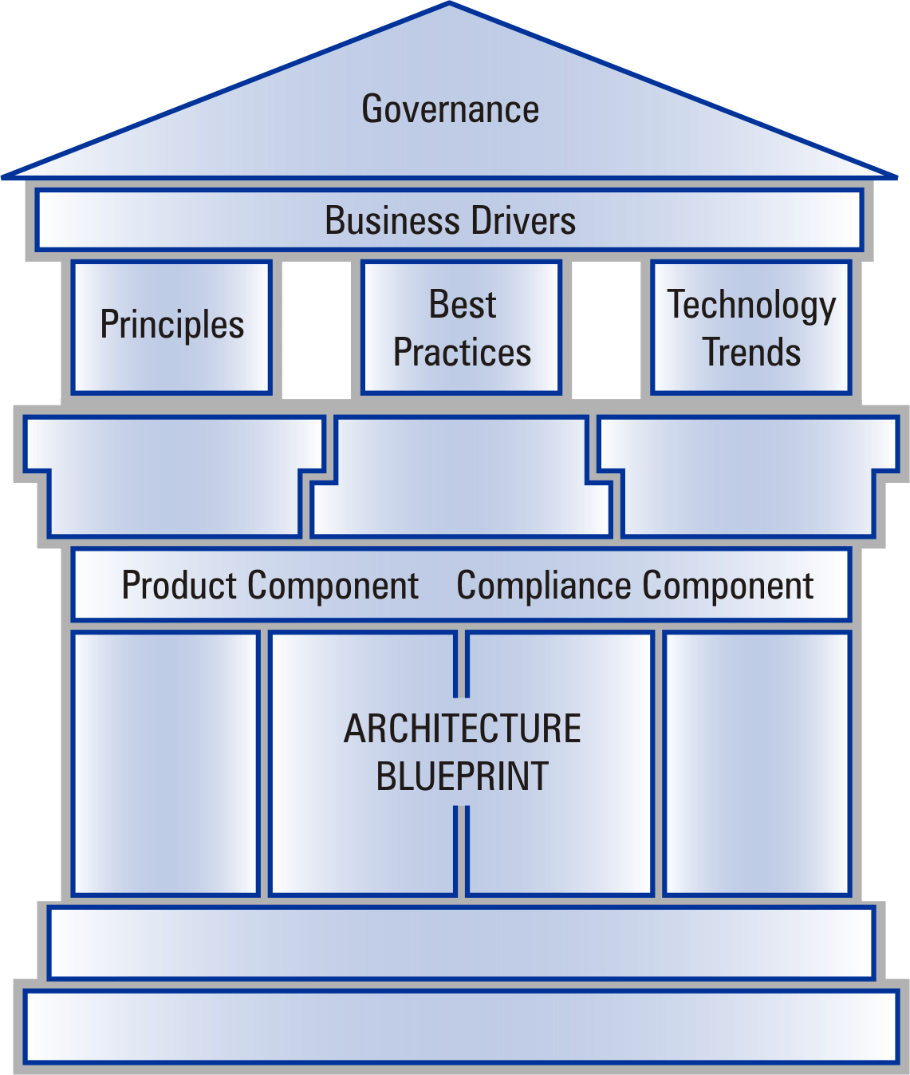
The following diagram, Figure 3, introduces the concept of the Missouri Adaptive Enterprise Architecture Framework and the Enterprise Architecture Pillars. These pillars, the Principles, Best Practices and Technology Trends, are overarching and support the Business Drivers. This diagram also demonstrates how the Architecture Blueprint is the foundation of the MAEA and how Governance covers all aspects of the Enterprise Architecture framework.

To fully understand these pillars, one must understand how all three Enterprise Architecture Pillars are related. The relationship has two aspects:

- The migration between the three pillars.
- The compliance requirements against which the documentation of the Architecture Blueprint will be compared.

Migration

The migration between the pillars identifies the potential for the upward migration of the documented Principles, Best Practices, and Technology Trends based upon the determined level of importance to the State. This includes the upward migration that can occur over time when:

- As a Technology Trends is proven over time and matures, it can be escalated to a Best Practice.
- A Best Practice can be reviewed by the state and be designated a Principle the state wants to guide the architecture.

Thus within the three Enterprise Architecture Pillars an upward migration can occur.

Compliance

Even though each of the assets that make-up the architecture pillars have the capability for upward migration, and have to be considered at the appropriate level by the Architecture Blueprint, the compliance requirements for each pillar are unique.

Enterprise Architecture Pillar compliance requirements are as follows:

- Principles - Architecture Blueprint assets cannot be in conflict with this pillar. If a conflict is found, it must be documented on the Domain Template, and a recommendation to change the principle must be submitted to the Architecture Office. The Architecture Review Committee should reevaluate the Principle for potential change or reject assets that are causing the conflict.
- Best Practices – Architecture Blueprint assets can be in conflict with this pillar. If a conflict is found, it must be documented and submitted to the Architecture Office for review. Approval to proceed or halt will be provided by the Architecture Review Committee.
- Technology Trends – Architecture Blueprint assets can be in conflict with this pillar. In the Domain Template, denote that a conflict exists and explain what the conflict entails.

Value of the MAEA

The nature of data processing has changed greatly in recent years. Today’s system users have more computing power at their desktops than mainframes had just a decade ago. Each year, new and better applications, software, hardware and peripherals are being developed. Each advance offers new opportunities to increase processing capability and improve service to constituents of the State of Missouri.

Every change state agencies or departments make to parts of a system, whether to take advantage of new technologies or to respond to business changes, potentially affects many other parts of the statewide IT portfolio. Furthermore, the systems built today must be capable of integrating with those that are built tomorrow. Creating an Enterprise Architecture environment that is adaptable to such change requires a detailed plan, processes and the commitment of all stakeholders.

The Architecture Blueprint must identify the individual components of the architecture to be used in the development of systems and must also ensure that those components work together for the benefit of the whole. The Architecture Pillars provide the guidance for the selection and implementation of computing platforms, software, networks and related standards and guidelines that interconnect the systems and ensure their interoperability which, in turn, supports the State’s business objectives and goals.

The standards and guidelines in the Architecture Blueprint will serve to support those who are making technology-based decisions for the State of Missouri. Rather than resorting to out-of-context, ad-hoc studies to facilitate strategic IT decision making, IT Managers can look to the MAEA and Architecture Blueprint for guidance and direction to capitalize on the technologies of the future while preserving today's investments. The goal is to enable the State of Missouri to optimize its systems and make the whole greater than the sum of its parts. By encouraging standardization of products and processes that are compatible with the architecture and by providing guidance to planners, designers and implementers, the MAEA represents a major step toward optimal, cost-effective resource utilization.
The Missouri Adaptive Enterprise Architecture (MAEA) Manual presents the guidance and approach for development and administration of the Missouri Adaptive Enterprise Architecture
The goal of state-wide Enterprise Architecture is to enhance coordination, simplify integration, build a consistent infrastructure, and generally allow greater efficiencies in the development of technology solutions.
The pervasive use of the Internet is one of the primary drivers of Enterprise Architecture.
Both the information technology community and state government leaders have determined that information technology architecture is a strategic issue that must be addressed.
The State of Missouri has established a close alliance between the IT community and the Division of Purchasing and Materials Management to help facilitate and manage IT procurements.
… e-government will be the flash point around which Missouri’s initial architecture domains will evolve.
The Missouri Adaptive Enterprise Architecture is governed by a well-defined set of roles, responsibilities, and processes.
Supporting Enterprise Architecture requires the involvement of personnel in a variety of roles and responsibilities.
Every department will assign an Architecture Manager.
The ARC provides a central focal point for ensuring the vitality of the IT architecture, overseeing architecture management processes at the statewide level, and initiating relevant domain committees for the support of e-government and other state business initiatives.
Every architectural domain will have an Architecture Domain Committee that is responsible for developing proposed standards and maintaining the domain content.
The Architecture Governance processes are an integral part of the overall IT management processes that are used to implement technology solutions within the State.

The Architecture Blueprint articulates the State’s architecture, showing classifications for products and compliances as emerging, cur-rent, twilight, and sunset.
The architecture is not intended to restrict organizations but is intended to enhance coordination and integration, simplify implementation, build a consistent infrastructure, promote inter-operability and generally provide for greater efficiencies.

The enterprise business drivers document the business direction of the enterprise and help to ensure that the application of information technology supports the business of the State.
The State of Missouri Enterprise Architecture represents a target IT environment for the State.
Best Practices identify industry processes related to the implementation of the architecture that will assist in the maintenance and expansion of an adaptive statewide technical architecture.
Technology trends have a significant impact on the business and architecture requirements of state government.
The MAEA begins with a conceptual framework that provides a simple and familiar structure that can be used to understand how the various components are related and interact with each other in support of the Business Drivers.
Architecture Definition 3
Scope 4
Approach 4
Architecture Deliverables 5
Focus 6
Benefits of Enterprise Architecture 6
Architecture Governance Organization 7
CHAPTER 2: MAEA Organization and Administration 7
Organizational Roles & Management Responsibilities 7
Architecture Owner 7
Architecture Office 9
IT Architecture Manager 9
Architecture Executive Committee (AEC) 10
IT Advisory Board (ITAB) 10
Architecture Review Committee (ARC) 10
Architecture Technical Committee 11
Architecture Domain Committees 11
Architecture Governance Processes 12
Primary Processes 12
Associated Processes 12
Architecture Documentation Process 13
Architecture Review Process 13
Architecture Communication Process 13
Architecture Compliance Process 14
Architecture Vitality Process 14
Change Management Process 15
Management Processes 15
Enterprise Business Drivers 16
CHAPTER 3: Business Drivers 16
Enterprise Guiding Principles 18
CHAPTER 4: Principles 18
Enterprise Best Practices 23
CHAPTER 5: Best Practices 23
Enterprise Information Technology Trends 25
CHAPTER 6: Technology Trends 25
Enterprise Architecture Pillars 27
CHAPTER 7: Conclusion 27
Migration 27
Compliance 28
Value of the MAEA 28

