Surplus Property (Web Data) Guide

Pages 2–3 | Logging in (password set up/expired and submitting SS1)
Page 3 | Variation for vehicle locations and online information form
Pages 4–7 | Finish rejected SS1 for local disposal
Page 8 | Suggested ways to pull reports (helpful for inventory control)
Page 9 | Trade-in request and current task

GETTING STARTED WITH WEB DATA

Go to the Missouri Surplus Electronic SS1 data base using Microsoft Edge or Google Chrome:
https://statesurplusv2.state.mo.us/Login.aspx (website WILL NOT work in Internet Explorer)

If Google Chrome or Edge is not set as your default browser – any link received in email will have to be copied into either of these browsers.
Log in with your state email address and hit FORGOT PASSWORD. You will be sent an email with a link to reset/setup the password and requirements of 15 characters that includes a capital letter, number, and special character. This is the same process when your password expires approximately every 60 days.

If it says EMAIL IS NOT REGISTERED, please contact us so we can update the account profile.

You are now logged onto the Missouri Surplus Property Electronic SS1 database - Web Data 2.0.

SUBMITTING AN ELECTRONIC SS1

Gather information about the property you plan to surplus including: DESCRIPTION, QUANTITIES, FUNDS, FA INVENTORY #, S/N, and MODEL.

To create an SS1:
- You can use SS1 request button near top of page OR on the panel to the right
- Choose Agencies
- Choose SS1 Request
- Choose New SS1 Request on bottom of page

Glossary of terms and process order:

- Contact Person: It will auto populate the name of the person creating the SS1.
- Who Will Authorize: Choose from drop down who in your agency will approve (possibly yourself).
- Disposal Type: The majority of the time, you choose TURN INTO SURPLUS.
- Pickup Type: The majority of the time, you choose REMAIN IN PLACE (Vehicles: may choose from drop down for SELF DELIVERY–if bringing to MOSASP).
- Add New Item: Click the button in the middle of page and the information box will pop up (highlighted in RED are required fields, but more will be needed).
- Building: Choose the address of property location from drop down menu (if location is not shown, let us know, and we can add it).
- Fund: From which the items were originally purchased, as this will be used to reimburse those funds.
- Item Category: Choose BEST MATCH from drop down menu, then save.
- Quantity: Amount of item(s) with same funding source, unless each have their own FA inventory #. Each FA inventory # will have to go on its own line.
- Condition: Choose one of the following – EXCELENT, GOOD, FAIR MAJOR REPAIR, or SALVAGE from drop down menu.
- Asset #: This is your state inventory or Fixed Asset # (if none, leave blank). Entering available asset #s are very important.
- VIN/Serial #: If item is a vehicle, the system will auto populate information from the VIN entered. Make sure you still enter the mileage in the description since that is unknown by the VIN decoder system (see “Variations for Vehicle Locations” below). The VIN decoder will populate information only if you hit tab after VIN. An online vehicle form will be generated for completion.
- Description: Longer descriptions with greater detail will help sell (example: defects, missing parts, known issues, vehicle information for year, make, mileage, etc.); OR, if the point of contact is different, that information can go here as well.
- Photo Attachment: Photos are attached using the IMAGES box, located under the Description. This will allow you to browse and upload photos of items, which will go on GovDeals for sale. All line items now require a photo submission in the IMAGES box, even requests for LOCAL DISPOSALS and/or SALVAGE.
- Document Attachment: This is used for other Word, Excel, or PDF information pertaining to the items.
- Save Line Item and REPEAT for all items.
- Clone Last Item: Cloning like-items is an option, which allows you to adjust information needed (example: quantity, FA #, fund) on the same type item.

The system will assign a SS1# to your listing, which can be used for tracking. If needed, you can write down the SS1# or print the listing.

When all items have been entered, click SAVE for later or SAVE & REQUEST AUTHORIAZATION (the red bar at very bottom of page under list of property entered).

The AUTHORIZATION REQUEST will be emailed to the person identified in step two. The authorization request allows them to approve it from the email.

You, the creator, will receive an email once your SS1 has been approved.

Variations for Vehicle Locations:
In the PICKUP Type field:
- Choose, SELF DELIVERY if bringing to MOSASP or,
- Choose REMAIN IN PLACE if selling on-site. Also provide the vehicle online form, which is generated from VIN DECODER.
- Photos must be provided by using the images box.

The following must be included in the Description box, along with any other notes you feel MOSASP should know about this vehicle: odometer reading, make, model, condition, with any known issues or missing parts.
Asset # is your agency Tag #. Serial # is the VIN.

If you have chosen SELF DELIVERY, and you are bringing the vehicle to MOSASP, print the approved electronic SS1 and bring it along with the title when dropping off the vehicle.

All vehicles will have to have the title mailed or delivered on location at MOSASP. Please print and include the SS1 with the titles.

If your agency has a separate location that houses titles, you will need to request the title to be sent to MOSASP. Please include the SS1 with your request, which can be attached to your email.
FINISH REJECTED SS1 FOR LOCAL DISPOSAL

MOSASP may reject items. This rejection is MOSASP authorizing LOCAL DISPOSAL.

After your SS1 is rejected, you will get an email on how to do the process.

**********************************************************************************************
“Dear
The item (Doodad) on SS1 Request # XXXXX is rejected.

Reason: The disposal type you selected has been rejected by Surplus for this item. Please add this item to a new SS1 Request as indicated by its new disposal type.

Please login and go to SS1 Requests. There you will see the “Rejected Items” tab highlighted. Create a new disposal request and choose “Local Disposal” as the disposal type. Next, click the “Add Items…” White button and select “Add Rejected Items”. That will show your rejected items in a pop-up screen. Select the items to be assigned to the SS1 and click the “Add Selected” button to assign the item(s) to the SS1. Then close the pop- up and continue with your normal SS1 Approval process.

Click here to login.

Thank you,
Missouri State Agency for Surplus Property”
***********************************************************************************************

THE FOLLOWING SCREENSHOTS DETAIL HOW TO FINISH LOCAL DISPOSAL

Log onto the website and go to: MENU > AGENCY > SS1 REQUESTS
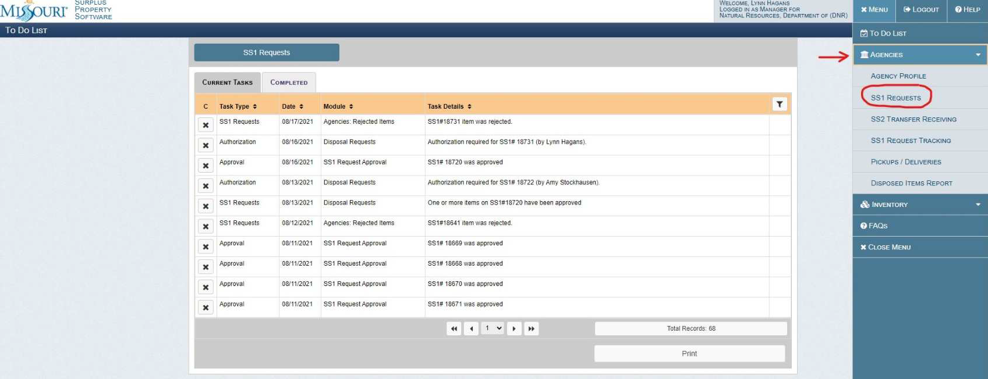

When you click on the SS1 REQUESTS tab, the rejected tab is now highlighted since there are rejected items.
Click on the REJECTED ITEMS tab to view the items.
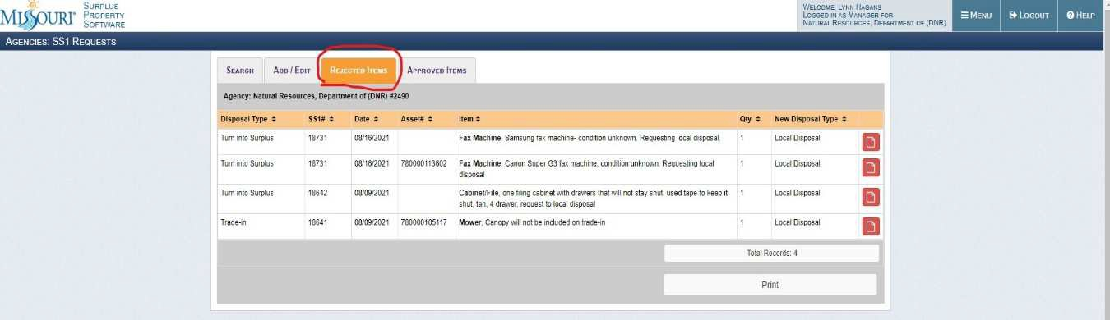

Click on MENU > AGENCY > SS1 REQUESTS
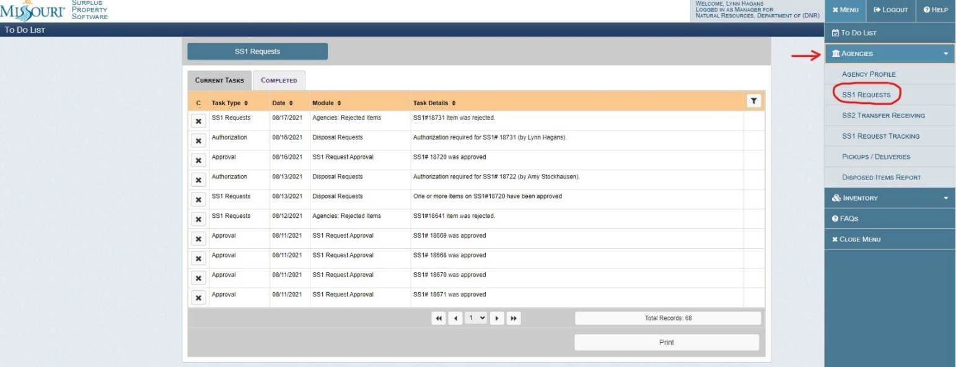

Click on: NEW SS1 REQUEST
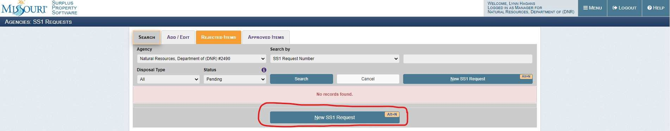

Choose LOCAL DISPOSAL on the Disposal Type drop down menu.
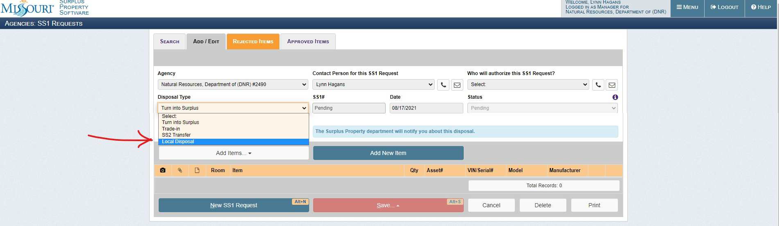

Complete the HOW WAS THIS DISPOSED and WHO WAS THE WITNESS fields. Click on the white ADD ITEMS tab and choose, ADD REJECTED ITEMS.
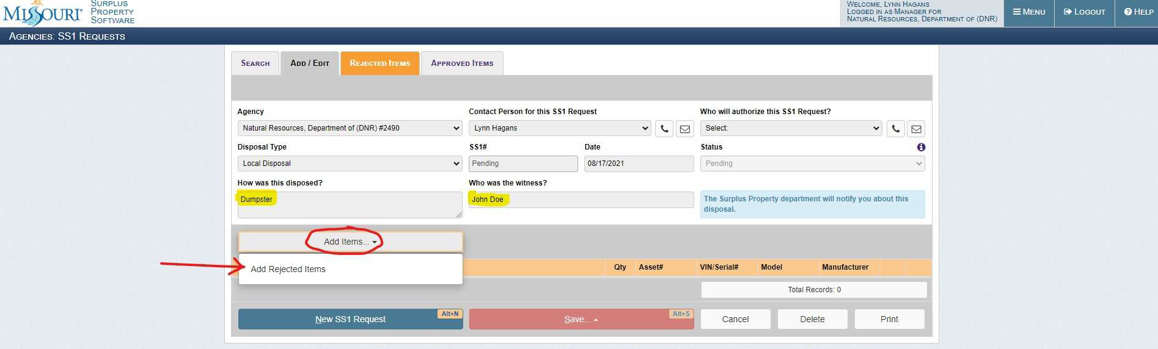

Click on the white check mark box on the right side of the item. It will turn green when it is selected. Click ADD SELECTED.
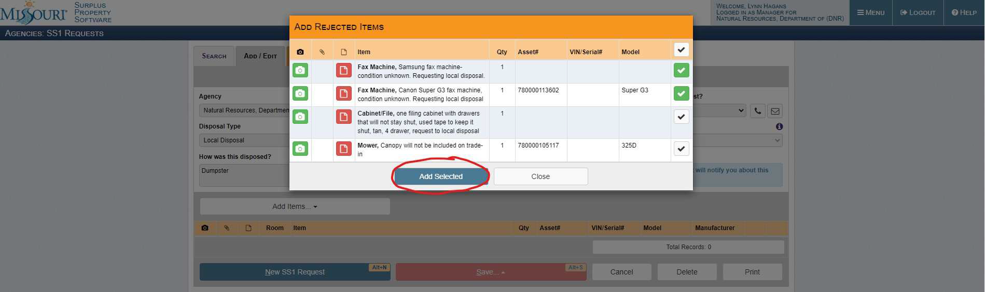

Choose the person authorizing the SS1 from the drop down menu.
Click SAVE and choose, SAVE AND REQUEST AUTHORIZATION from the dropdown menu.
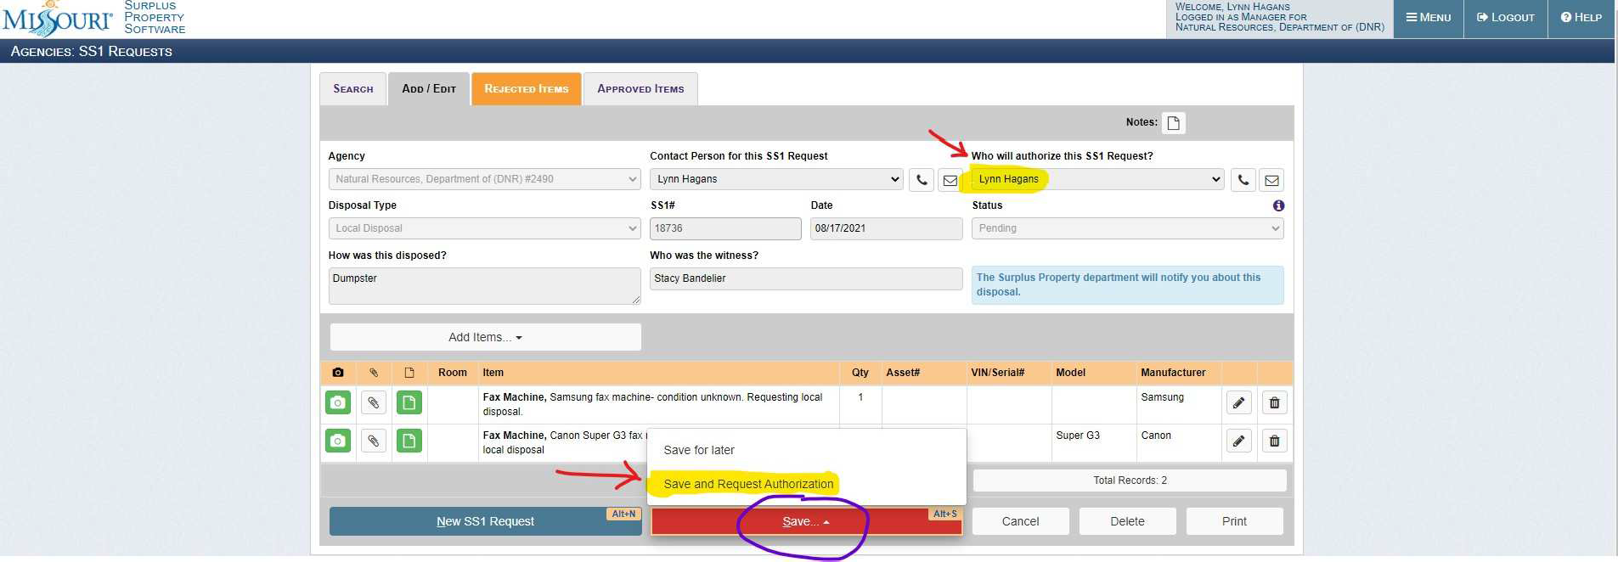

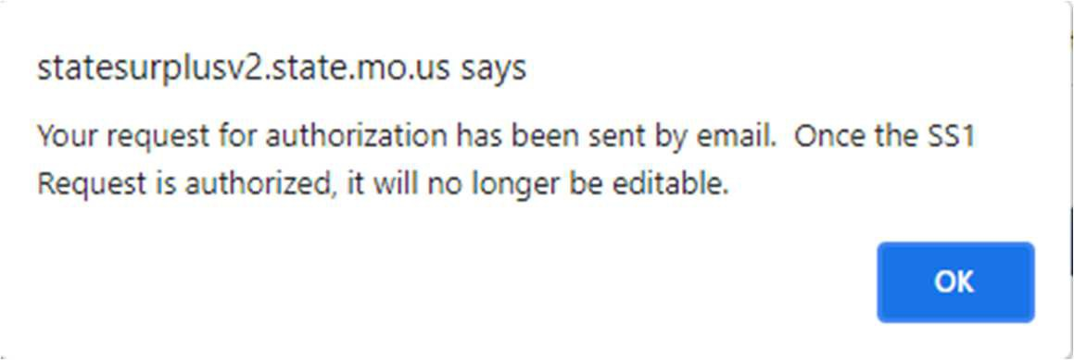
A pop up box will appear as below and you are done
SUGGESTED WAYS TO PULL ASSET REPORTS

To view/print SS1 forms:

Menu > Agencies > SS1 Request
You can enter the number in the box next to SEARCH BY SS1 request number or leave the SEARCH BY box empty and change the DISPOSAL TYPE box and STATUS box set to ALL – hit SEARCH (this populates a complete list).

To view/print items invoiced or sold on GovDeals
(This report can be exported to excel.)

Menu > Agencies > Disposed Items Report
Click SEARCH with no criteria to get a complete list. You can sort on screen by any column heading or you can export and sort in excel (there is a filter button to the right, that gives you the option to key in specific search in each column)

To view/print local disposals
(This report is not exportable.)

Menu > Agencies > SS1 Requests
Choose LOCAL DISPOSAL on the disposal type drop down menu, and choose ALL from the STATUS from drop down menu. Since this is not exportable and item descriptions not shown on screen, you will have to hit the print icon to view, if the SS1 contains items in inventory to adjust, you have the option to print.
(If not, just close and view next one – repeat.)

TRADE-INS and SS2 transfers can be viewed the same way, just choose TRADE IN or SS2 from the drop down on DISPOSAL TYPE and ALL under STATUS.
TRADE IN REQUESTS

Create SS1, except on the DISPOSAL TYPE, choose, TRADE IN (not TURN INTO SURPLUS).

This will generate more fields to be completed (i.e.: Trade in Vendor, Trade in Value and Requisition #) Once you or your authorized individual approves the submission, MOSASP will get the request. If approved, an approval email is sent and the SS1 will now show as completed.

If you need a copy, just log in and search by SS1# or DISPOSAL TYPE, print for your records.

CURRENT TASKS (To do list)

This is the list that shows upon log in in the Web Data system. This list should be cleared or updated periodically by someone in your agency.

To clear/update this list – click on X in the first column, which indicates completed

MOSASP contact information:

Michelle Collier michelle.collier@oa.mo.gov 573-522-4865

Dennis Scott dennis.scott@oa.mo.gov 573-522-4892

Lee Ann Blythe leeann.blythe@oa.mo.gov 573-751-0454

